WASTE TYPE | GREEN | YELLOW | PURPLE | RED | SHARPS | BLACK | BLUE | BURGUNDY
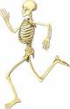  Anatomical | 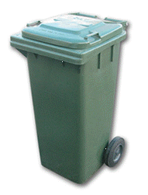 | 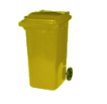 | 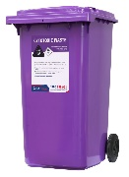 | 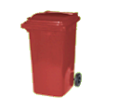 | 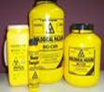 | 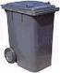 | 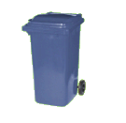 | 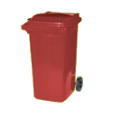
 | ☐ | ☐ | ☐ | ☐ | ☐ | ☐ | ☐ | ☐
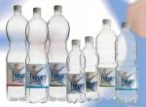  Plastic |  |  | 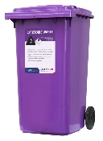 |  | 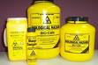
 | ☐ | ☐ | ☐ | ☐ | ☐ | ☐ | ☐ | ☐
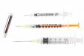  Needles |  |  | 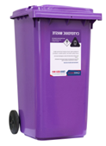
 | ☐ | ☐ | ☐ | ☐ | ☐ | ☐ | ☐ | ☐
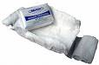Dressings |  |  | 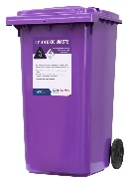
 | ☐ | ☐ | ☐ | ☐ | ☐ | ☐ | ☐ | ☐
  Paper |  |  | 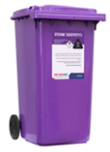
 | ☐ | ☐ | ☐ | ☐ | ☐ | ☐ | ☐ | ☐
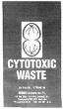  Cytotoxic |  |  | 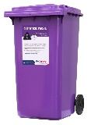
 | ☐ | ☐ | ☐ | ☐ | ☐ | ☐ | ☐ | ☐
  Food Scraps |  |  | 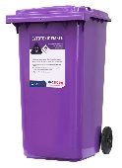
 | ☐ | ☐ | ☐ | ☐ | ☐ | ☐ | ☐ | ☐
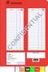  Confidential Paper |  |  | 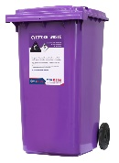
 | ☐ | ☐ | ☐ | ☐ | ☐ | ☐ | ☐ | ☐
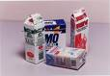

Cardboard
 | ☐ | ☐ | ☐ | ☐ | ☐ | ☐ | ☐ | ☐

