Participant Guide

Contributing to Health and Safety of self and others in the Workplace

Introduction
Welcome to the unit Contributing to Health and Safety of self and others in the Workplace.
Workplace Health and Safety (WHS), also known as Occupational Health and safety (OHS) is a crucial aspect of any person’s working life. Injury and even death at work, is still a high statistic in Australia. It is very important you understand how to conduct your work safely so that you and your colleagues can be effective at work and return home safely.
Previously WHS policies focussed mainly on physical safety at work, whereas today WHS also refers to cultural, psychological and mental wellbeing at work.
The Victorian Public Sector (VPS) is governed by legal and ethical codes to ensure a safe workplace, appropriate resources and guides for safe work practices. As an employee of the VPS, it is your responsibility to follow these safe work practices to comply with WHS laws.
This unit describes the skills and knowledge required to understand, follow and participate in the WHS activities in your organisation.

Agenda
This unit will be taught face to face over two days.
The course has been designed to develop skills and knowledge in key areas:
• follow all relevant procedures and instructions relating to work health and safety (WHS) and emergency incidents
• identify and report hazards to designated personnel
• contribute to WHS consultative processes.
We will cover
- Work Safety

Classroom Expectations

1. This is a safe learning environment where rich discussion and questioning material is encouraged as well as respecting difference of opinion.
2. On occasion discussing individual cases can add value to our discussion but remember to maintain confidentiality and change names or circumstances.
3. There is a lot of information to cover and if there are issues raised outside the scope of training the trainer will follow up with the participant individually.
4. Please ask questions at any time during the training.

Assessment Tasks for Contributing to Health and Safety of self and others in the Workplace
- Assessment Task 1 – Knowledge questions
- Assessment Task 2 – WHS inspection

WORK SAFETY

As a Victorian Public Servant (VPS) you are required to understand and follow the legal and ethical principles that relate to work, health and safety (WHS) in your workplace. It is important to be aware of the laws related to your WHS obligations.

WHS Legislation
There are a number of laws underpinning safety in your workplace. These laws outline the responsibilities of both employers and employees to work in a safe manner. Failure to comply with workplace procedures and thus laws, is a criminal offence. You may have heard of companies who have been fined for failing to comply with WHS laws. Individual employees can also be fined under health and safety legislation if they cause an accident or are careless and do not follow safety procedures or use equipment safely.
Some of the main and common WHS laws you may know include:
• Occupational Health and safety Act 2004
• Public Health and Wellbeing Act 2008
• Working with Children Act 2005
• Public Health and Wellbeing Regulations 2019.

VPS WHS Framework
Under the Victorian Occupational Health and Safety Act (2004), every employer is responsible to make sure the workplace, resources and culture allows for you to conduct your work in a safe and productive manner.

You may be familiar with the Victorian Public Service (VPS) governance framework called Leading the Way.
Each government department’s WHS policies will differ slightly depending on the industry they work in. For example, the Department of Education (DET) is committed to the following WHS activities:
• Preventing workplace injury
• Enhancing workplace culture
• Consulting collaborating and communicating with employees, health and safety representatives and other groups within the department
• Allocating adequate resources
• Providing transparent and robust information, training and instructions and documentation
• Driving continuous improvement.
You were most likely inducted to your organisation’s WHS policies when you first began your job. Often that is a busy time, and you may not have retained all the information. Following the WHS procedures for your organisation is your responsibility.
Each workplace should have the documents readily available to you to ensure you understand your obligations. These should include
- Government WHS regulations
- Regulations related to your industry WHS
- WHS emergency incident procedures
- VPS code of conduct
- Work safety plans

Psychological safety
The VPS takes a zero-tolerance approach to workplace bullying and/or violence at work. This is in line with various legislation such as the Anti-discrimination Act, 2004; Racial discrimination Act 1975 etc.
It is important to be clear on what defines workplace bullying.
There is legislation within the VPs that aims to protect workers from discrimination. These include
- Age Discrimination Act 2004
- Disability Discrimination Act 1992
- Racial Discrimination Act 1975
- Sex Discrimination Act 1984
- Australian Human Rights Commission Act 1986.

Activity 1
Watch the video - https://youtu.be/nVeXxrh_OHQ and answer the following questions.
Question | Answer
- What are the two criteria for defining workplace bullying?

2. List four examples of unreasonable behaviour for the workplace.

3. List three other people besides employers and employees who are included in your workplace anti-bullying policies.

4. List five examples of reasonable management actions, which do not constitute bullying behaviour.

5. List three ways bullying can be dealt with at work.

Office pre-start checks
Ergonomics is the study of the physical interface between a worker and the way they use their tools or equipment. Physical factors affect the health and performance of the worker. Good ergonomic design allows a worker to use their equipment, be it machinery, computer, workstation etc. so as to avoid discomfort, strain or injury to the body. Here are some ergonomic ways to ensure your work is conducted safely.
To work safely and minimise the risk of personal injury, you must set up the area where you use your computer correctly. This area is called a workstation.
A workstation will include your desk, chair, computer/monitor, keyboard, and mouse. It will also include other business devices you place on your desk such as your phone, paper, pens, lamp etc.
If your workstation is set up incorrectly, you risk musculoskeletal injury (damage to your muscles, bones, ligaments, and nerves) and eye strain. Musculoskeletal injuries can be painful and cause ongoing damage to your health and well-being.
Fortunately, setting up your workstation correctly, taking regular breaks, and performing stretching exercises will minimise this risk.

Workstation setup
The first thing to set up or check is the positioning of your chair and computer equipment.
You should have a computer desk that is approximately 700mm in height and an ergonomic office chair allowing seat height adjustment and back support adjustment.
When seated at the desk, you should position the computer equipment as shown below.
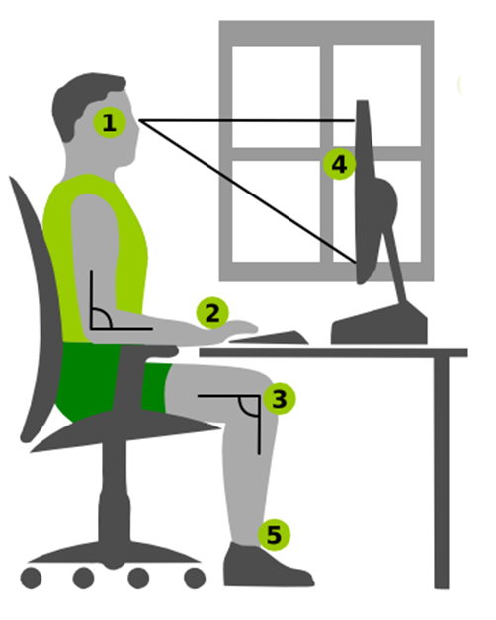
1. The top of the computer monitor should be in line with your eyes when looking straight ahead.
2. The keyboard and mouse should be on the same level as your elbows and palms
3. Your elbows and upper and lower legs should be at 90-degree angles.
4. There should be a distance of at least 50cm (approximately your arm length) from your eyes to the computer monitor screen.
If there is a window in the room, the monitor should be positioned to the window at right angles.
5. Your feet must sit flat on a firm surface. A footstool under your feet can be used to achieve this if necessary.

Work environment
There are other environmental factors to consider in order to work safely and minimise the risk of personal injury.
1. Lighting
There must be sufficient light to enable you to see clearly without the need to strain your eyes. This light may come from fluorescent tubes, tungsten or halogen lights, or natural lighting from windows.
Your computer monitor should be positioned sideways to windows to avoid eye strain and fatigue. Additionally, you should make sure there are no other light sources or reflective surfaces causing glare on your computer monitor.
2. Airflow and quality
The air conditioning system controls the air quality and air flow in many buildings. These systems should be regularly maintained and adjusted to ensure sufficient clean air is provided. In addition, where possible clean, fresh air should be introduced through windows.
3. Thermal comfort
Thermal comfort relates to the temperature and humidity in the work environment. Although there are individual differences between people in their preferred temperature and humidity levels, a level of general comfort should be obtainable through heating or air-conditioning systems. Different office areas may have differences in temperature (for example, under an overhead heating duct).

Work Tasks
It is important to plan your work tasks so you can vary your activities, take regular breaks and stretch. Sitting at a computer for extended periods takes a physical toll on your body. It is important you take regular breaks to allow the muscles you have been using, an opportunity to rest and recover.
As you saw in the video, stretching is important to allow your body to change position and your muscles to relax.
Example stretches include:
• Chin tuck – keeping your back straight, tuck your chin in towards your neck.
• Neck stretch – keeping your back straight, tilt your head to the left side, then to the right side of your body.
• Shoulder squeeze – squeeze your shoulder blades together while expanding your chest.
• Lower back – Holding the top of your back straight, push your pelvis forward.
Performing these exercises frequently will help reduce tension in your back, neck, shoulders, and arms. It will also help to keep you alert and focused on your work.
Eye muscles can also become tired from focusing intently on a computer monitor. To prevent tired or strained eyes, regularly change your focus away from the computer monitor. You can do this by looking at something at a distance, for example, looking down the length of a corridor or across a large room or looking out a window at something in the distance. Regularly changing the focus of your eyes will help to prevent eye fatigue.
It is recommended when working on a computer at a workstation you:
• take a break and get up from your computer at least once an hour
• stretch parts of your body approximately every 15 minutes
• regularly relax your eyes.

Mental Health Tips
It is also important to consider how you can maintain your own mental health and safety while conducting your work.

Emergency Incidents at work
Emergency incidents which can occur in any workplace include:
• fires
• explosions
• chemical leaks and exposure
• trips and falls
• medical episodes such as heart attack, epileptic fit, diabetic fit etc.
All workplaces are legally obliged to provide signage, procedures, training and practice runs such as fire drills, for all staff, to enable a swift and controlled response to any emergency incident which may occur.
Common signs, such as the ones below, will direct you to important information or equipment you may need in an emergency. Make sure you look around your workplace and locate where the emergency equipment is stored.

WHS and Emergency Incidents Policies
As an employee, you are obliged to understand and follow the policies and procedures related to WHS and emergency incidents. These procedures contain key information to help you deal with emergency situations in your workplace, such as:
• names and contact details of the fire wardens, WHS officers and key personnel
• the alarm system, emergency warning and intercommunication system used in the building
• contact details for local emergency services e.g. fire brigade, police, ambulance
• actions that employees are required to take in response to alarms
• evacuation route/s to be taken
• evacuation procedures including arrangements to assist any hearing, vision or mobility impaired people
• map of assembly area or designated alternative areas which provide a safe refuge internally or externally
• how the end of the evacuation will be signalled
• what is required at the completion of the evacuation
• reporting notifiable incidents.

Who Should respond?
Always refer to your workplace emergency procedure so you know who should respond or who to contact in an emergency. VPS workplaces have designated fire wardens, first aid officers, WHS representatives to contact should an emergency occur in your workplace. Make sure you know who these people are in your workplace.
However, there may be a situation where you are the closest and therefore the first responder to an emergency and your quick actions will be vital. Make sure you know where the local numbers are for:
• Nurse on Call
• Ambulance
• Police
• medical centres closest to your workplace.

Every workplace must have a first aid kit to be available in the case of minor or sometimes major injuries. We often don’t think about them until we are in an emergency situation.
Make sure you know:
• where your first aid kit is located
• what its basic content are or should be
• who is responsible for replenishing supplies
• how to provide basic first aid such as stopping a bleed or dressing a cut.
When first aid training is offered, always take the opportunity to learn these skills. You never know when you will need to use them, especially if the nominated first aider is absent or on leave or you are the first responder.

External Emergencies
Other emergency incidents may occur outside of your workplace but will impact your response to WHS, such as:
• natural disasters, e.g. bushfires, floods, storms
• nearby fires, explosions, electrical outages
• shooting or bomb threats in the city
• pandemics e.g. COVID 19, influenza
In these situations, it will be important to follow the advice of your WHS representative, manager or designated personnel. The COVID 19 pandemic, which began in 2020, caused a massive re-think of how to keep employees safe and well at work, from an infectious, airborne disease. Governments, unions and health authorities worked quickly to develop COVID safe working practices.

IMPLEMENT WORK SAFETY REQUIREMENTS
This topic will look at the ways WHS is implemented in your workplace. It will cover the role of WHS duty holders, health and safety representatives; identifying and reporting workplace hazards; implementing procedures and instructions and reporting emergency incidents. Let’s look first at what is meant by the term duty holder.

WHS duty holders
Under OHS laws, everyone has a duty of care to create a safe work environment, maintain safe work practices and act in a safe manner when in a workplace. Under OHS laws these are often referred to as duty holders.
Duty holders include
- Persons conducting a business or undertaking (PCBU) such as an employer
- Officers such as owners or operators of a small business, individuals who make significant decisions in a business or those who can affect a business financial standing
- Workers and other in the workplace (Safe Work Australia)
- Clients, visitors, customers and anyone else who visit the site where you work are duty holders

Designated WHS reps
Every VPS department will have a health and safety representative (HSR), representing the WHS needs of a designated work group (DWG). A DWG may be a separate government branch or department or a smaller group of employees such as the finance or IT team.
A HSR’s role may vary slightly between departments but often includes tasks such as:
• attending management meetings to discuss and present WHS concerns
• inspecting workplaces for WHS risks
• reporting on addressed and unaddressed WHS issues to management or externally if required
• representing individual needs of employees in the DWG such as employees with disabilities or language difficulties.

Identify, report and record hazards
As a WHS duty holder, you are responsible for identifying hazards and keeping the workplace safe and healthy for all workers and visitors. Any hazards or WHS issues need to be reported to the health and safety representative (HSR) in your workplace and if they are absent, then directly to your manager. Let’s take a closer look at common workplace hazards.
Workplace Hazards
Some of the most common type of accidents in workplaces often relate to tripping and falling. Objects left in walkways, deliveries not put away in a timely manner, electrical cords left lying across floors and walkways, spills and leaks which cause people to slip, are all too common. Manual handling of goods, such as boxes of photocopy paper stored up high above shoulder length, increases the risk of employees being hit by falling objects or suffering musculoskeletal damage.
Hazards in your workplace can be classified as:
Hazard | Example
Mechanical | Tripping hazards such as chords, filing cabinets that can tip when full etc.
Physical hazards | Glare or reflection from screens; poorly designed workflows that require a worker to be in one position for long periods of time.
Chemical hazards | Vapours in the air such as paint solvents, photocopier toner etc.
Psychological or Psycho-social hazards | Unrealistic deadlines or overload of tasks which can cause stress; lack of unsatisfying work; workplace bullying or harassment, discrimination
Electrical hazards | Damaged electrical cords; overloaded PowerPoints that may lead to electric shock.

Hazards in a workplace are often identified by:
• observation using WHS Hazard identification checklists
• consulting with colleagues about WHS issues
• regular scheduled WHS audits
• checks conducted by HSRs
• reviews of any incident and accident reports
• WHS inspections conducted by external regulators or auditors.

Hazards versus risk
When we talk about workplace hazards we often also refer to the risks involved.
A workplace Hazard is anything that can cause harm to an employee.
A risk is the likelihood that harm or injury may occur.

WHS Risk Assessment
Workplaces must have a system for identifying hazards and conducting WHS risk assessments. It will usually involve the following steps.
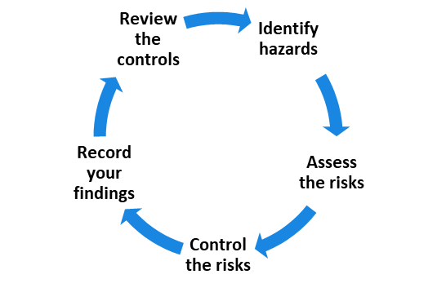

Activity 2

Break into three groups and each group take a scenario and answer the questions and feed back to the group.
Scenario 1 - A delivery of photocopy paper arrives from the supplier. The receptionist is away and so the boxes are left in the hallway.
Scenario 2 – A worker enters a secure building and forget to close the door properly allowing access to anyone who walks past the door
Scenario 3 – An electrical cord is placed across the room right before a presentation and anyone entering the room has to walk over it.

What is the potential hazard?
How many people may come into contact with this hazard or be affected?
How likely is it that a worker may be injured or harmed?
How would you rate the potential consequence, if an injury/accident occurred?
What is the risk rating?

HSRs and managers often apply a risk matrix to rate the likelihood of a hazard causing harm or injury and the impact of the consequence, if an injury or accident did occur.
First the hazard is identified, then the likelihood of an injury occurring is identified by selecting from almost certain to rare, (down the left-hand column).
The next step is to rate the consequence; if an injury or accident did occur how would you rate the consequence from minor to catastrophic (across the top row).
The rating of low, medium, high or extreme, will inform the risk mitigation strategy, designed by managers, to prevent an incident occurring at work.
With a partner, discuss the scenario below and use the Risk matrix above to identify the risk of the hazard.
Your HSR will often be involved in the risk assessment of your workplace but as an employee you also have a responsibility to:
• follow your WHS procedures
• report hazards and incidents
• be involved in risk management when required
• provide input into the safe working practices of your organisation
• suggest improvements to reduce incidents or illness.

Reporting Hazards
The quicker hazards are identified, reported and dealt with, the safer the workplace is for yourself and others. Reporting hazards is every employee’s responsibility and is often done informally and verbally when you see the HSR. However, it can be helpful to report the hazard via email, so the HSR has:
• a record of the conversation
• a prompt to take action
• a trail for monitoring the time it takes to get WHS problems resolved.
Some workplaces will have an online hazard register which automatically notifies the HSR. Always refer to your workplace WHS policies and procedures for reporting hazards.
What is your organisation’s preferred way of recording hazards?

Common Hazard Signs and SAFETY SYMBOLS
Signage, posters and labels are strategies used in the workplace to remind and alert people to dangers and help prevent accidents/incidents from occurring.
Australia uses standardised colour schemes for safety signage in industries, to make safety symbols universal and more easily recognised across industries.
Symbols and visuals are important for employees who may speak a language other than English or who are more visual learners. Hazards vary in different workplaces and industries, but there are some common hazard symbols used across industries.

Report emergency incidents and injuries
In Victoria, the Occupational Health and Safety (OHS) Act 2004, requires all employers to:
• keep a written record of any workplace accidents
• notify WorkSafe of any dangerous incidents
• keep information regarding WHS of employees.

Some of these reports may be called incident reports, first aid reports, workers compensation claim forms. As part of this process, all employees are required to report any emergency incidents, accidents or near misses as quickly as possible. Let’s clarify these terms commonly used in emergency reports.

Your organisation will have forms and templates to complete should an injury at work occur. These forms are kept on file in case employees need to claim for medical expenses and/or work cover; they can also be used as evidence in court cases. Therefore, the reports need to be written in clear, legible English and signed off by your WHR and/or manager.
An emergency report will usually include details of:
• the date and time of the incident/accident
• the location
• name and details of the injured person
• what occurred (factual account)
• the injury sustained
• names of witnesses
• first aid or treatment administered.
An emergency or incident report contains a section for the employee, the HSR and the manager to sign. See a sample emergency incident report below.

WRITTEN COMMUNICATION
Remember these incidents reports may be read by your manager, CEO, HSR, Worksafe regulator, compliance auditors, police or used in a fair work claim court of law, so it is important that you write clearly and legibly.
When completing an incident report:
- use clear, short sentences
- write a factual account of what you saw/did
- avoid descriptive words or embellishing the story
- use correct grammar and spelling
- avoid writing other people’s responses or comments unless they directly impacted the incident.

NOTIFIABLE INCIDENTS
Some workplace incidents are notifiable under OHS laws. Notifiable means they must be reported to Worksafe Victoria.

Participate in WHS consultative processes

WHS consultative activities
Employees often have the most knowledge of the risks or harm which can occur when completing daily tasks, using certain machinery/equipment and relating to staff and customers, so good WHS management will involve consultation with employees.

Consultation often takes place when:
• identifying hazards and/or risks
• deciding how to control the risks
• designing employees work spaces such as work areas, factories, bathrooms etc.
• developing procedures for WHS
• setting up health and safety working committees
• proposing changes to production, workplace tasks, expanding business etc.
• complying with OHS laws.
Consultation may take place via:
• team meetings
• online surveys
• HSR groups
• Interviewing.

Regardless of which methods your workplace uses to consult, all effective consultation should:

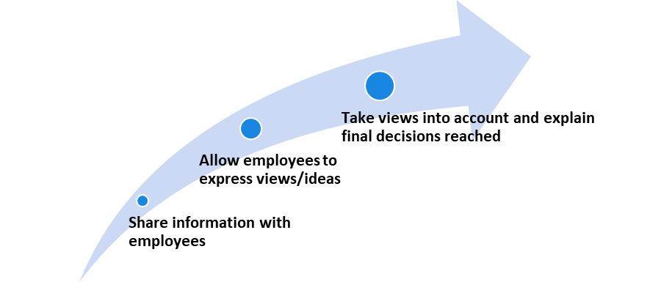

Raising WHS issues
As you saw in the video, being involved in WHS at work creates a safer and more satisfying work experience for everyone. Each workplace will have a procedure or a process to follow for raising and resolving WHS issues in the workplace. Let’s take a look at the process DET uses to resolve any WHS issues.
CLEAR COMMUNICATION
When attending WHS meetings, speaking up about WHS issues or being asked your opinion of WHS in your workplace, always be mindful of your audience and the impact your words will have. Ask yourself:
• Is it appropriate to bring up this issue in this meeting?
• Has this issue been raised before and not been received well by others?
• How can I stress the importance of dealing with this issue without yelling or becoming angry?
• Who can support me to raise this issue?
• What solutions can I suggest for dealing with this issue?
If you were asked to report on a sensitive issue such as witnessing bullying or discrimination in your workplace, make sure you follow the VPS values of honesty, respect, impartiality and integrity and:
 provide accurate and factual information of what you observed
 relay specifics, about times, dates, people involved and what was said/observed
 do not omit any important details
 do not repeat hearsay or stories you have heard
 do not speculate on the reason for the incident
 do not attempt to lay blame or give your own opinion.

SUPPORT FOR MORE COMPLEX WHS ISSUES
Some WHS issues may be straightforward, easier to discuss and resolve such as broken furniture or poor lighting etc. Other WHS issues such as discrimination or workplace bullying may be more complex and difficult to raise.
In the case of an incident involving workplace safety (which includes bullying and harassment), you should follow the established process and promptly report the incident by contacting the authorised WHS officer for your organisation using the correct channels. (See topic 2.5)
People who can assist you to raise complex issues such as discrimination or sexually inappropriate behaviour at work, may include:
• Your Health and Safety representative (HSR)
• A supervisor you trust
• Risk and compliance officer
• Union representatives and OHS specialists
• Worksafe representatives
• Fair Work Australia, Ombudsmen.

Eliminate workplace hazards
The goal of any organisation is to eliminate workplace hazards completely, however this is not always possible and therefore a system for controlling risks in the workplace is used, called the hierarchy of control. The hierarchy of control is a step-by-step approach to eliminating or reducing risks. The strategies at the top of the pyramid are more effective and therefore prioritised over those at the bottom.
See the Hierarchy of Control diagram below.
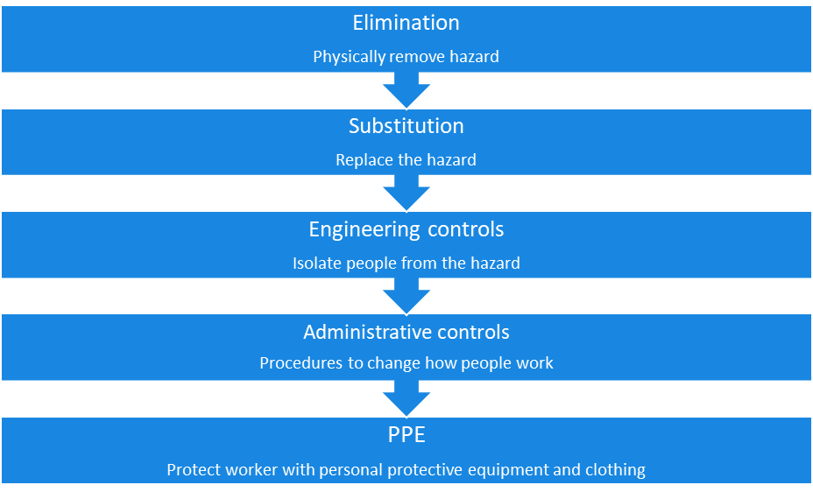

CONTROLLING PSYCHOLOGICAL HAZARDS
As we saw earlier, hazards which may cause psychological injuries, may not be as obvious as physical hazards, but they still need to be eliminated or controlled.
Watch this 3-minute video – What are work related factors? by Worksafe Victoria.
What are work related factors?

