Mobile assessment with Mobas
Student guide

Section heading
Section heading 2
1. Introduction to Mobas 3
1.1 What is Mobas? 3
1.2 System Requirements 4
1.3 Application features 5
1.4 Getting started 6
Contact Information 8

1. Introduction to Mobas

1.1 What is Mobas?
This guide is designed to help you get started in using Mobas, a mobile web application that allows you to complete workplace assessment in any location with your mobile device.
The site address to log into Mobas: https://studentweb.bhtafe.edu.au/hosted/mobasapp/#!/login

Mobas allows you to:
- Compete assessments using your supported Apple or Android mobile device in a workplace setting.
- Attach text, photos and videos to assessment submissions.
- Communicate with your teacher and workplace supervisor using the comments feature
- Send assessments to StudentWeb (Learning Management System) when a wifi connection is present.

Mobas assessment types:
Work Diary | Allows students to complete journal entries across a period of time, adding text and up to two photos per entry
Job Safety Analysis | Allows students to assess the level of risk, harm, and control measure for a hazard or risk
Practical Task Capture | A customised technical report with result and solution evidence
Safe Work Methods Statement | SWMS is a site-specific statement that must be prepared before any high-risk construction work is commenced. This allows students to identify risks and hazards that may be involved and how these can be controlled
Demonstration checklist | Allows the student to attach up to five photos per performance criteriea to demonstrate a particular task/requirement
Video Demonstration | Record a live video to demonstrate a particular task/requirement.  Note: Due to file size limitations, video files are unable to be saved offline. Any videos recorded should be submitted immediately to avoid loss of work. A one minute recording is approximately 8MB. You need to ensure your internet connection download/upload limits allow for uploading of files this size

1.2 System Requirements

Mobile device specifications
For the best Student experience it is recommended that your device meets the following minimum specifications:
Device type | Android/Apple
Operating system | Android 8+ / iOS 11.0+
Features | Camera
Network connectivity | Wi-Fi enabled (minimum)
Video requirements | Must be online  1min = 8MB, 5min = 30MB
Storage space | 100MB

Computer specifications
If you don’t have access to a mobile device you can complete all assessments in StudentWeb Learning Management System. Please ensure that your computer meets the following requirements:
Internet Connection | 512kbps or greater
Screen Resolution | 1024x 768 or greater
Internet Browser | Internet Explorer 9 with Windows 7, though Internet Explorer 8 with Win XP is OK  www.microsoft.com/windows/internet-explorer/default.aspx  Google Chrome 22 or later (fast) google.com/chrome  Mozilla Firefox 15 or later (fast) www.mozilla.com/en-US/  Safari 6 or later (Note: there are known issues with the text editor used in StudentWeb)  Opera 9 or later.
JavaScript | Enabled

1.3 Application features
Feature | Icon | Function
Log in | 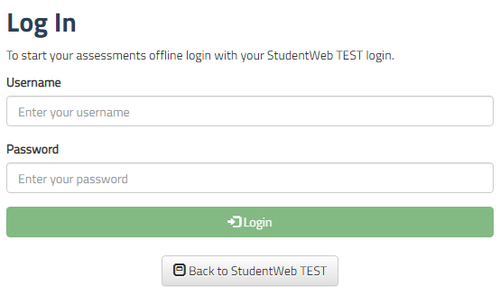 | This is the Mobas log in screen. You may use any device to log in. Once you log in on your mobile device, you will not have to log in again to the same device.
Check System Requirements | 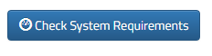 | If Mobas is not operating select this botton to check the Operating System Requirements
Back to StudentWeb | 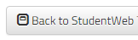 | This provide the Student access to StudentWeb
Dashboard | 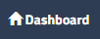 | Select this button to go back to the home page that lists your units.
Settings | 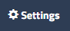 | The setting button shows more details about the Web application like;  - The current version of Mobas  - Who the logged in user is  - The last logged in time  - And the ability to clear all data
My units | 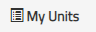 | List all units that contain Mobas assessments.  There may still be assessments in StudentWeb that do not use the Mobas application.
Onine |  | This advises your are currently logged in.
Logout | 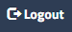 | This will allow you to log our of the application.
Clear all data | 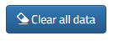 | Warning: This will clear all data including any unsubmitted assignment submissions. This button is located in the settings features.
Back key |  | Allow you to to navigate back one step at a time.
Unit / Number of Mobas assessments for this unit | 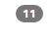  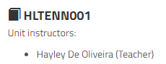 | Unit names are listed on the Dashboard screen along with the number of Mobas assessments per unit.  You will also see the name of teacher for each unit.
Assessments list |  | Once a unit is selected from the Dashboard you will see the list of assessments including the description of each assessments and the type of Mobas assessment.
View Assessment Description |  | Once an assessment is selected the assessment description is hidded, to view the assessment description select the “View Assignment Description” button
Close | 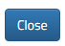 | Closes the screen without saving.
Take Photo | 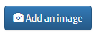 | Add an image allow you to take a picture using your mobile device, once taken you can decided whether or not you wish to use to take another. This also allows the Student to rotate the image once taken.  From a desktop vie, Students can upload images from their file browser.
Save Entry | 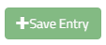 | A Student must save all entries for them to be able to preview their submission and submit their work.
Show comments / Add comments | 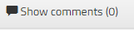  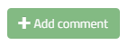 | Within each assessment, the Student, teacher and workplace supervisor can communicate by adding comments. Once a Student adds a comment they cannot remove the comment only the teacher can via StudentWeb
Hide comments | 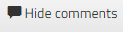 | The Student can hide all comments by selecting this button.
Work diary title and description | 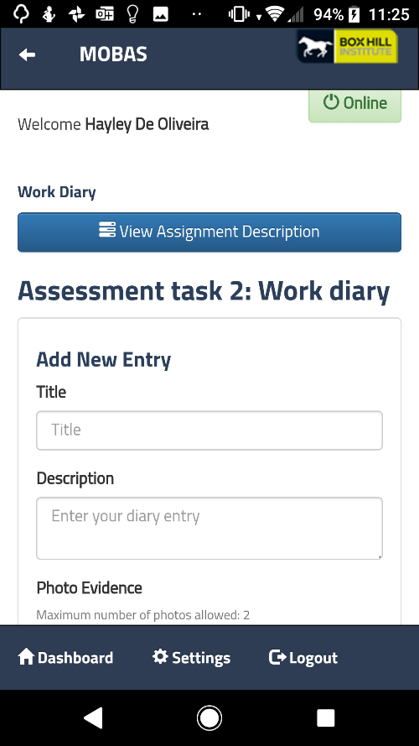
Job Safety Analysis | 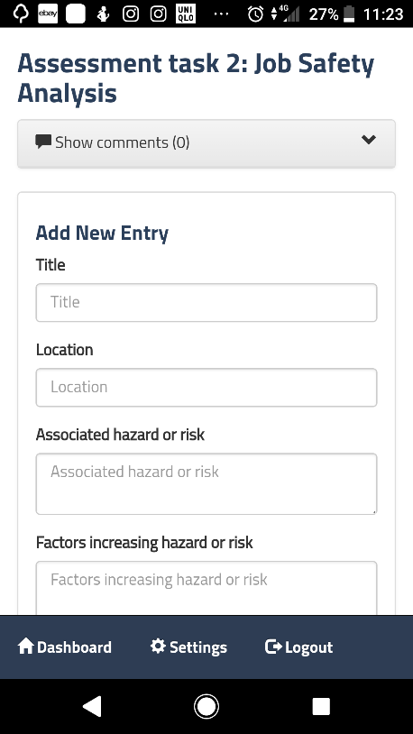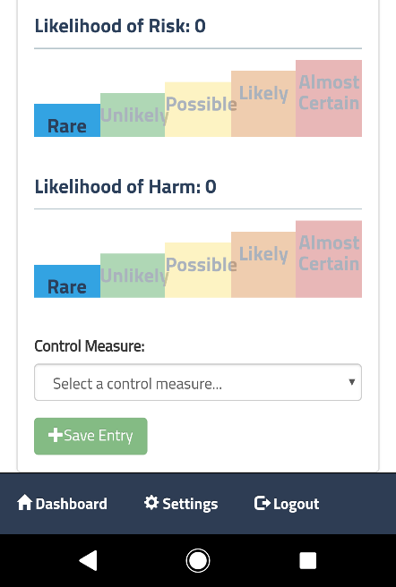
Safe Work Methods Statement | 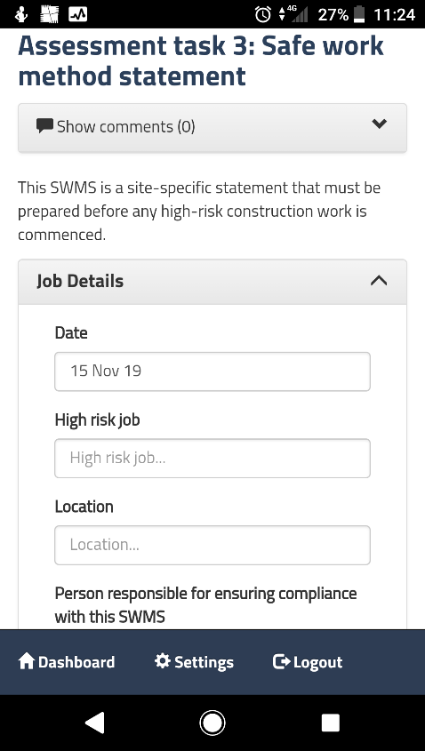
Demonstration Checklist | 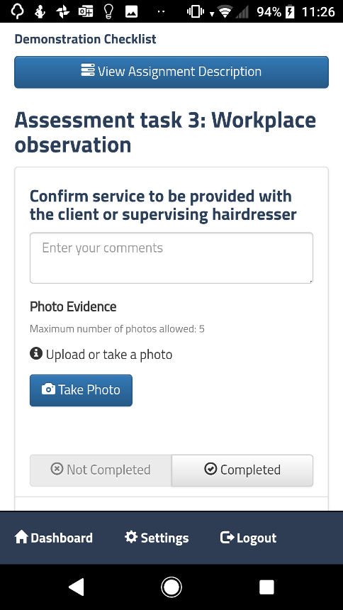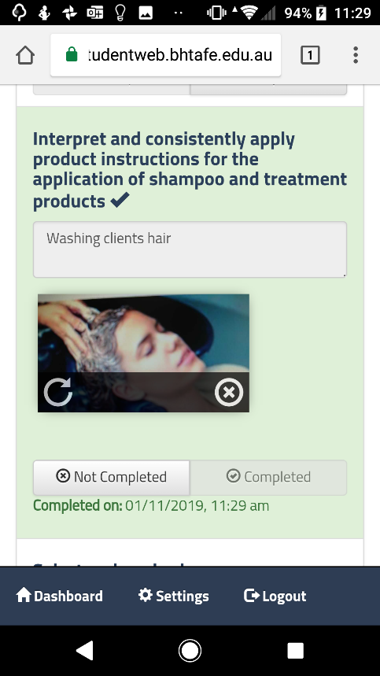
Practical Task Capture | 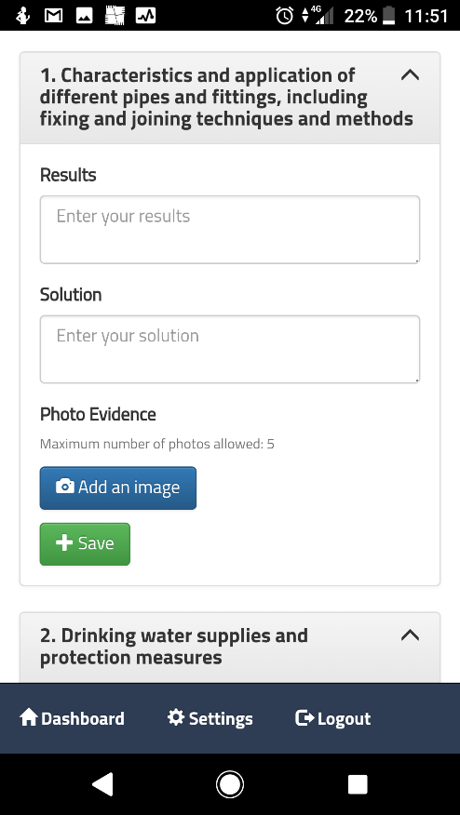
Video Demonstration | 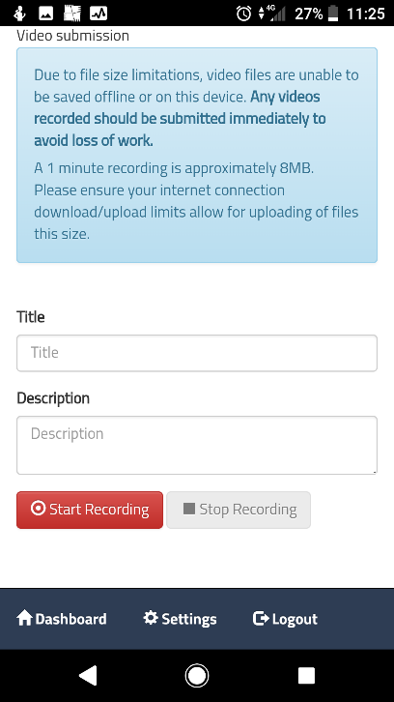  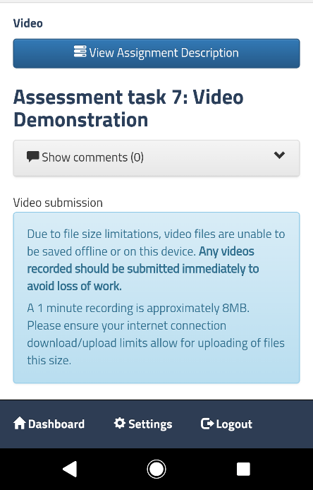
Workplace supervisor signoff required |  | Student will need their Workplace Supervisor to verify and signoff their assessment task on the job.  The teacher will identify which assessments require supervisor sign off and the Student will see this message within the Mobas assessment template
Complete / Not Complete | 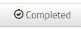 | Once a student completes a task they can select complete, their may be multiple tasks within an assessments before it is submitted, so this is a good way for the Student to keep track of what they have and have not yet completed.
Delete Entry | 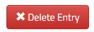 | Deleted entire entry, a warning message will pop up to ensure the Student does want to delete entry.
Preview Submission | 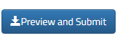 | Preview and submit allows the Student to review their final work before they submit to StudentWeb.
Tick box for authentication |  | Student must tick this box to ensure their submission is their own work, except where they have acknowledged the use of the work of other people.
Submit Assessment |  | This submits the work to StudentWeb. The Student must log into StudentWeb to check their grade and feedback.
Video submission details | 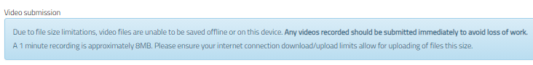 | Warning statements, explaining the data and storage requirements for recording a submitting a Video Demonstation
Record video | 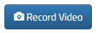 | Record Video allows the Student to record a video displaying a skill. Note: the Student may need to organise a peer or their workplace supervisor to record the Student.
Upload |  | Student accessing Mobas on the desktop allows the Student to seach and upload videos and images
Show All / Show Locked |  | Show all displays all assessments that are not yet submitted.  Show locked shows assessments that have been submitted. These assessments are locked until graded by the teacher.

1.4 Getting started
Download and install the Mobas app  Add link to the homescreen of your mobile/tablet desktop. | Android Instructions:  - Open Chrome  - Enter web address: http://studentweb.bhtafe.edu.au/hosted/Mobasapp  - Select the three vertical buttons on the top right-hand corner of screen  - Select add to home screen

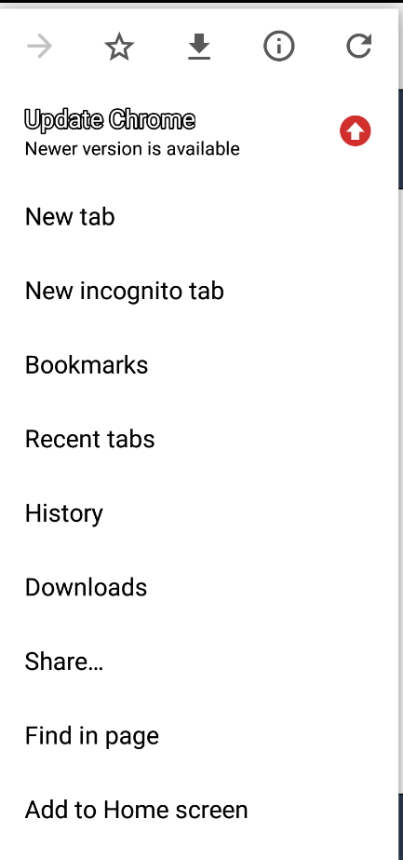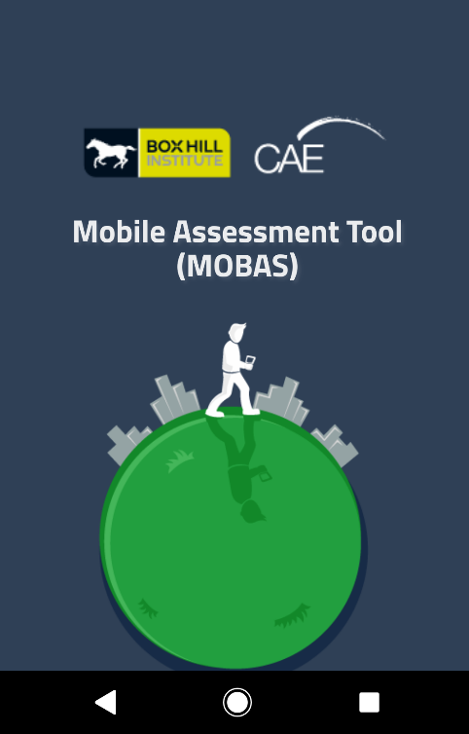
Type name of Web App: Mobas

Complete: Mobas has now been added to your home screen

Apple instructions
- Open Safari. ...
- Navigate to the website you want to save to your home screen. ...
- Tap the Share button at the bottom of the page.
- On the bottom row of icons, scroll over until you see Add to Home Screen and tap this.

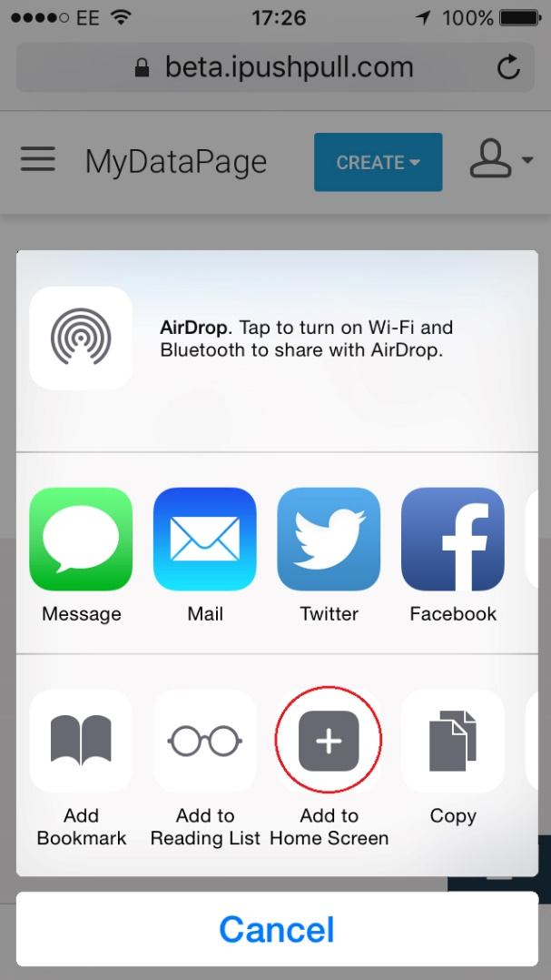
Select the ‘Mobas’ application icon on your device and Log in using your BHI network credentials, exactly as you log into StudentWeb | 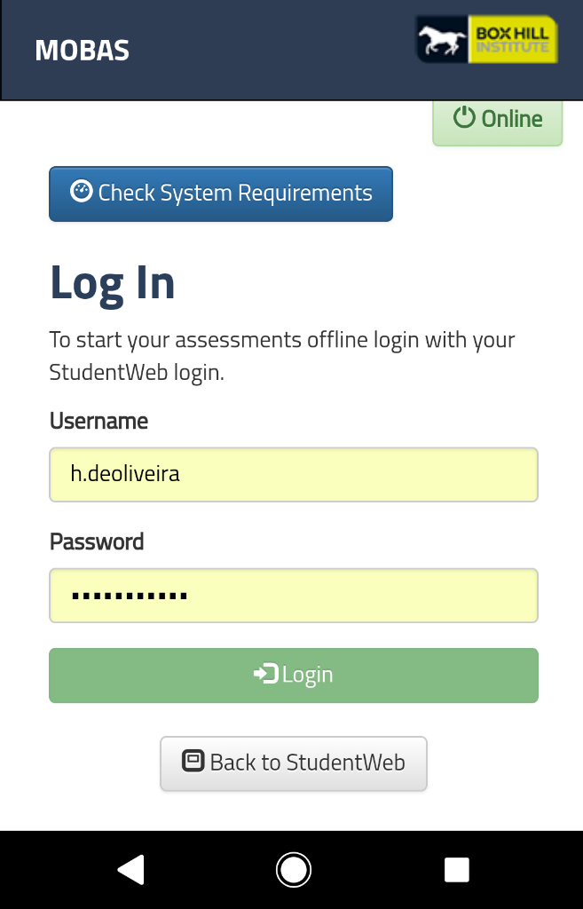
Units that you are enrolled in will appear*. Next to each unit title will be a number which indicates how many “Mobas” assessments need to be completed for that unit.  Select the unit for which you need to complete an assessment e.g. “SHSHBSS001”. | 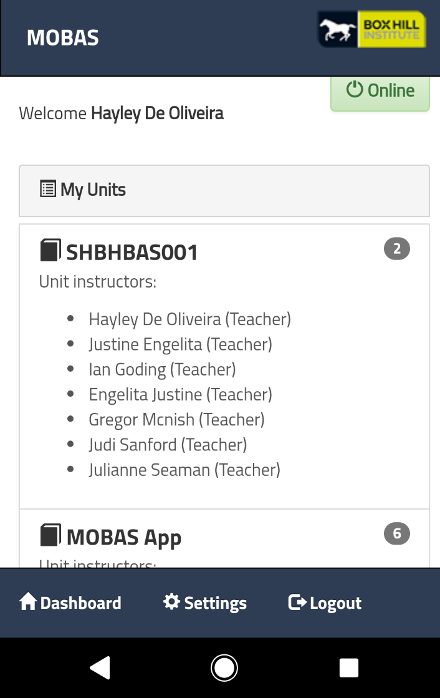
A list of assessments will be shown.  Select the assessment that you would like to complete e.g. “Assessment task 2: Work Diary” | 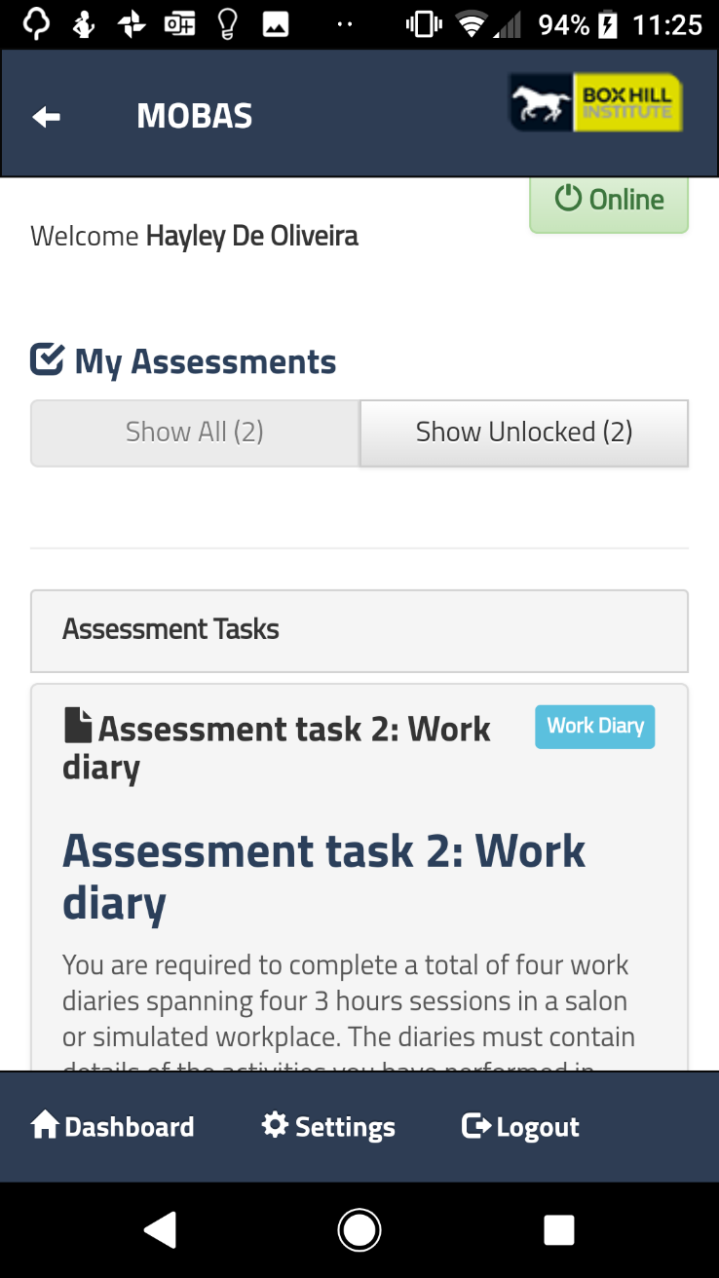
The Student can start any assessment select the assessment title. Clear written assessment instructions will guide the Student to complete and submit their assessment.  Note: If the Student saves but does not submit an assessment, they will be able to continue their work in Mobas. Once the Student is ready to submit they can preview their assessment first.  Each mobas assessment template has different expectations for the Student to complete.  At any stage the Student may view the Assignement Description as it presents in StudentWeb. | 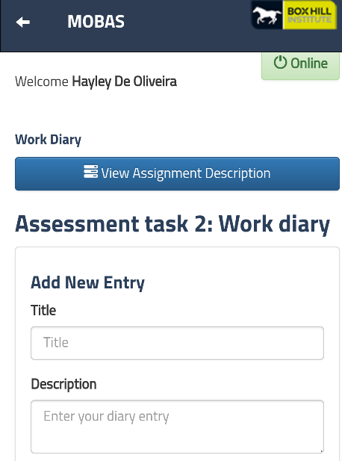  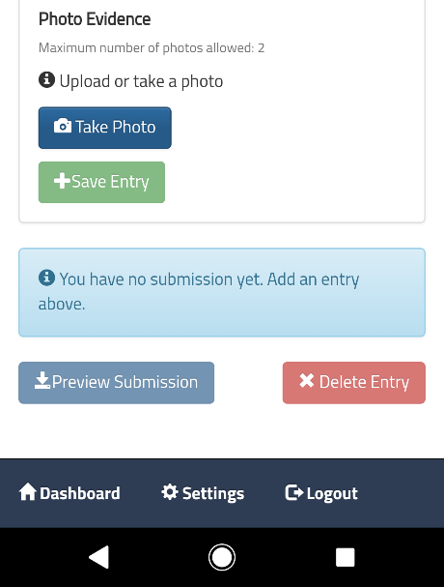

*Note: If you do not see any units appear please check with your teacher that you are correctly enrolled in your unit.

Contact Information

For further information regarding Mobas, please contact:
Name: Teaching Innovations
Phone: (03) 9286 9057

With the exception of the Commonwealth Coat of Arms, the Department’s logo, any material protected by a trade mark and where otherwise noted all material presented in this document is provided under a Creative Commons Attribution 3.0 Australia (http://creativecommons.org/licenses/by/3.0/au/) licence.

