In class Activity - RISK ASSESSMENT 1
Location: |  |  |  |  |  |  | Date:
Scenario:  Pathology Collection Centre | What is the harm that the hazard could cause? | What is the likelihood that the harm would occur? | What is the level of risk? | How effective are the current controls? |  | What further controls are required? | How will the controls be implemented?
 |  |  |  |  |  |  | Due date: | Person responsible for implementation:
Hazard:  Overfilled sharps container |  | ☐1. VERY LIKELY  ☐2. LIKELY  ☐3. UNLIKELY  ☐4. VERY UNLIKELY | ☐1. EXTREME  ☐2. MAJOR  ☐3. MODERATE  ☐4. MINOR | ☐EFFECTIVE  ☐INEFFECTIVE |  | LEVEL 1:  ☐ELIMINATE
LEVEL 2:
☐SUBSITUTE
☐ISOLATE
☐USE ENGINEERING CONTROLS
LEVEL 3:
☐USE ADMINISTRATIVE CONTROLS
☐USE PPE
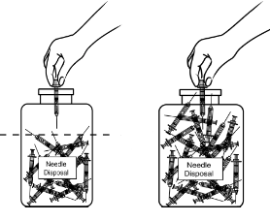 |  |  |  |  | Existing Risk Controls?
 |  |  |  |  | Residual Risks?
 |  |  |  |  | Comments:
In class Activity – RISK ASSESSMENT 2
Location: |  |  |  |  |  |  | Date:
Scenario:  Pathology Home Visit | What is the harm that the hazard could cause? | What is the likelihood that the harm would occur? | What is the level of risk? | How effective are the current controls? |  | What further controls are required? | How will the controls be implemented?
 |  |  |  |  |  |  | Due date: | Person responsible for implementation:
Hazard:  Slip, trip & fall hazard |  | ☐1. VERY LIKELY  ☐2. LIKELY  ☐3. UNLIKELY  ☐4. VERY UNLIKELY | ☐1. EXTREME  ☐2. MAJOR  ☐3. MODERATE  ☐4. MINOR | ☐EFFECTIVE  ☐INEFFECTIVE |  | LEVEL 1:  ☐ELIMINATE
LEVEL 2:
☐SUBSITUTE
☐ISOLATE
☐USE ENGINEERING CONTROLS
LEVEL 3:
☐USE ADMINISTRATIVE CONTROLS
☐USE PPE
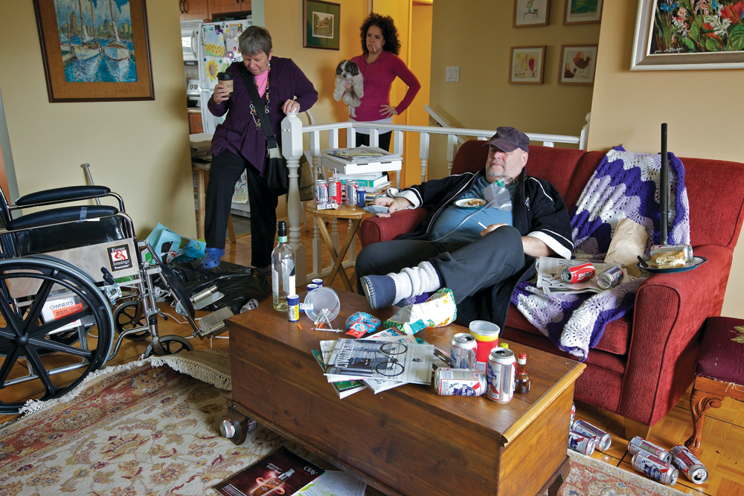 |  |  |  |  | Existing Risk Controls?
 |  |  |  |  | Residual Risks?
 |  |  |  |  | Comments:

