Australian Standards -Techstreet

Library guide

Box Hill Institute Library

studentweb.bhtafe.edu.au/library

City (CAE) Campus: Rooms B2.32 & 2.33, Second Floor, Building B (03) 8892 1684
Elgar Campus: Room E3.220, Level 2, Building 3 (03) 9286 983
Lilydale Campus: Room 290, Level 2, Building LA (03) 8892 2520
Nelson Campus: Room N1.G46, Ground Floor, Building 1 (03) 9286 9281

General information.

Current Box Hill Institute staff and students can access the full text of all Australian Standards, plus selected international standards from our online subscription.
Users must register for an individual account with Techstreet.
If you are printing standards in the library, please use the guide ‘Printing Australian Standards in the library.’
Standards can be saved to your device for use while you are a student, or staff member of Box Hill Institute. They can also be printed out in full, using the print button in the top tool bar of Adobe. Our licence permits one print out of a standard per user. Printed or downloaded standards must only be used by the person who downloads them.
Standards are not accessible via Remote desktop.
Our account only allows two users to access the Tech Street platform simultaneously. If you cannot access a standard, please try again later.

Registering for an account.

- Go to the Techstreet registration page at Open StudentWeb at https://studentweb.bhtafe.edu.au/mod/page/view.php?id=1014747
- Log in with your usual StudentWeb log in. (STAFF: Your PC login is also your StudentWeb login)
- The Standards registration screen appears.
- Complete the form, and select ‘Sign up’.
  - You must use your Box Hill Institute email address to register. Student email addresses are in the form sXXXXXXXX@student.bhtafe.edu.au where XXXXXXXX is your student number.
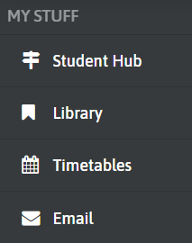
  - Select your usual campus as the location
- Check your Institute email address for an email from Techstreet with a link to create your password. Look in your junk email, if this does not appear in a few minutes. Your Box Hill email can be accessed from the left hand toolbar on StudentWeb
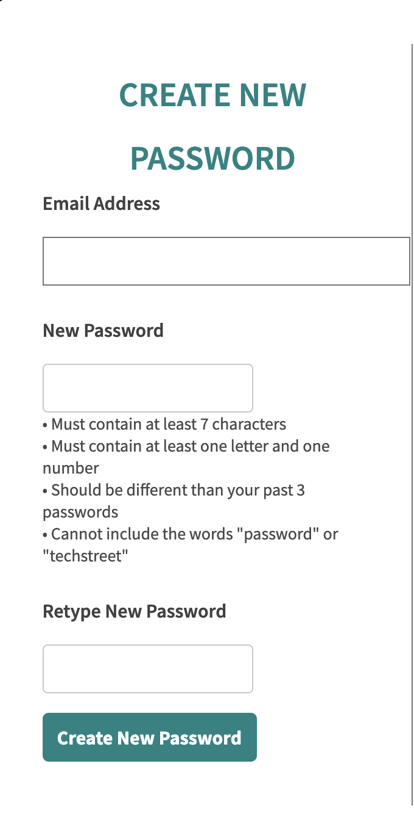
- You will be prompted to create a password. You will need to use this password, anytime you access standards.
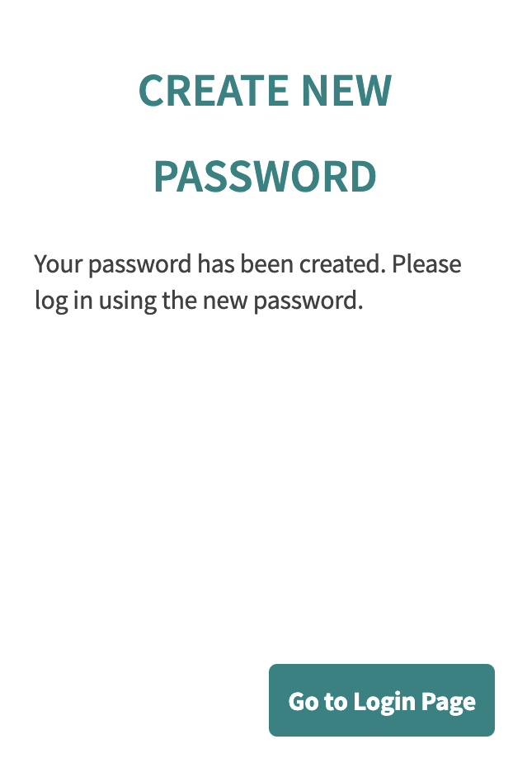
- You should get a message saying that your password has been created.

- Select ‘Go to log in page’ and login with your Box Hill email address and the password you just created

Installing software (if required)

If you want to print a standard, or download it to your device for later use, you must have Adobe Acrobat and FileOpen software installed on your device. If you just want to read a standard online, no special software is required on your device, and you can skip this section of the instructions.
Adobe Acrobat and FileOpen are already installed on many Institute PCs, including library PCs, and PCs in Buildings E1&E2. If FileOpen is installed it shows as a Third party plug-in in Adobe. Third party plug-ins can be seen either under ‘Adobe Reader’ or under ‘Help’ depending on your device, and the version of Adobe.
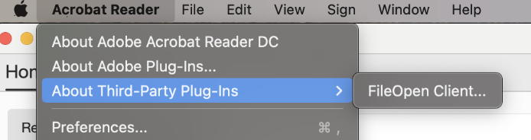

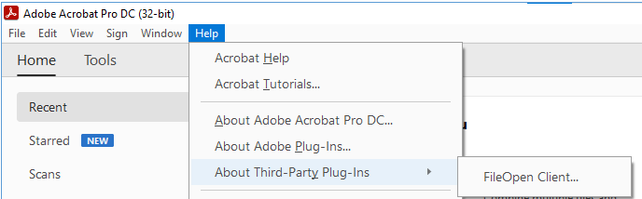

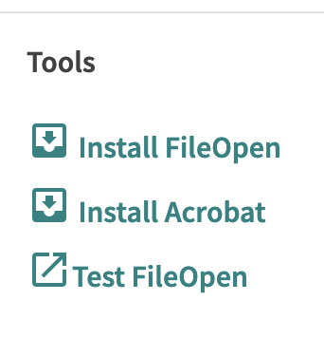
- If you need to install Acrobat, select the Install Acrobat link on the Techstreet homepage. Next, select the download button for Adobe Acrobat Reader DC, and follow the steps to download it. When the file has downloaded, click on it to install Adobe on your device.
- To install FileOpen on your own device, click the install FileOpen link on the Techstreet homepage. Select the appropriate version of FileOpen for your device. When the file has downloaded, click on the file to install it.
To install FileOpen on a staff device, open the Software Centre on your device. (Find this by typing Software into the search box at the bottom of your screen)
Select ‘FileOpen Client’ then install.
To install FileOpen on student PCs in classrooms, log a job with IT Services.
You should now be ready to access standards

Accessing standards

- Login to the Techstreet website at https://subscriptions.techstreet.com/sessions/new
- Search for standards by key word (e.g. electrical) or standard number (e.g. 3000) in the search box.

- To open a standard, click on the document title.
- If you want to print or save a document on your device, select ‘Download’ (remember that FileOpen and Adobe Acrobat need to be installed for this to work.
If you want to read the standard online, select ‘View online’ The standard should open in a new browser window. Note that you cannot print, copy or paste from this viewer.
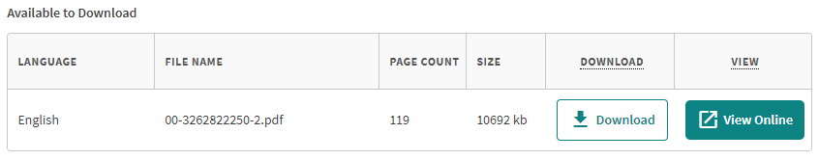

Opening downloaded standards on Institute PCs:

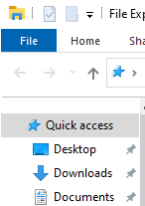
Once FileOpen is installed, downloaded standards can be opened on Institute PCs as follows:
- Open File Explorer, and select the Downloads folder
- Right click on the file, select ‘Open with’ and then Adobe Acrobat DC.

Opening downloaded standards on other devices
If the file is blank when opened, this often means that FileOpen has not installed. Check if FileOpen is installed, as described earlier.

iPhone:
If the standard is blank when opened, select the upload icon in the lower right hand corner of the screen, scroll along and select ‘FileOpen viewer’ as the app to use.

Chrome:
You may need to update settings in Chrome to download standards, rather than opening them in the browser
a. Within Chrome, select the three dots at the top right of screen, and select ‘Settings’
- Select ‘Privacy and security’ and then ‘Site settings’
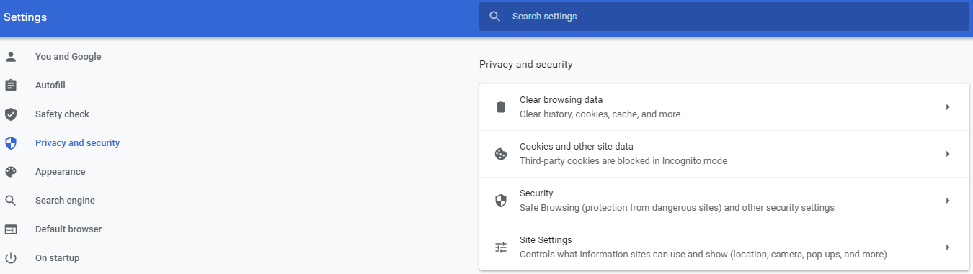
- Select ‘Additional content settings’ and then PDF documents
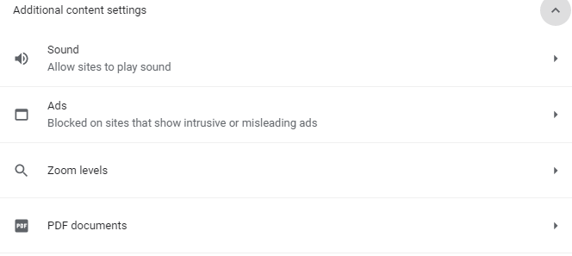
- Make sure that ‘Download PDF files instead of automatically opening them…’ is selected
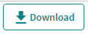
- Return to Techstreet, and select ‘Download’
- From the ‘Downloads’ folder on your device, right click on the file, and select “Open with Adobe Acrobat.”
- If Adobe does not appear as an option when you right click on the file, select ‘Open with’ and then chose Adobe.
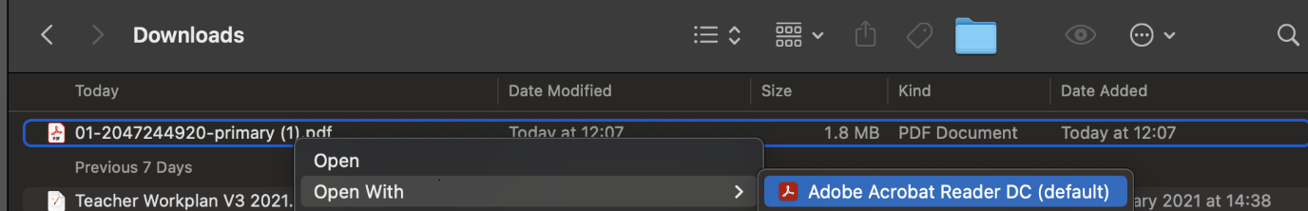

Firefox:
You may need to update settings in Firefox to download standards
- Select Firefox in the top menu of your browser, choose ‘System preferences’ and ‘General’
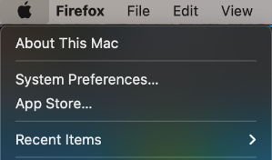
- Select ‘General’ and under ‘Applications’, find Portable document format (PDF)
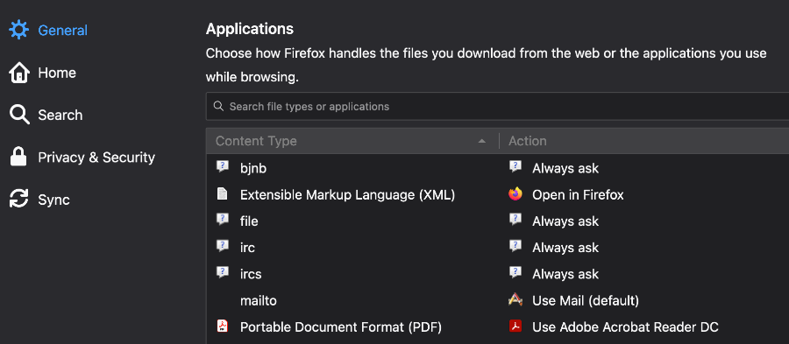
- Change the ‘Action’ for PDFs to ‘Use Adobe Acrobat’ (you may have to select ‘Use other’ then browse to find Adobe on your device, if it does not appear in the list of options.)

Printing standards
Once a standard is open in Adobe, it can be printed either on a home printer, or using a copier at Box Hill Institute. Our licence with Techstreet prohibits standards being printed at commercial printers such as Officeworks.
Students
To print standards from Institute PCs, refer to the Library guide: Printing Australian Standards in the library.
To print from your own device to a Box Hill Institute copier, refer to the Library Guide – Printing from a laptop. Once you have sent all standards to print, refer to the Library guide: Printing Australian standards in the library to learn about paying for printing, and having documents bound.

Staff
Staff can print standards at any Institute copier, and have them bound at BHI Print (E9.G24)
Staff can also get standards printed at BHI Print. This includes printing class sets of standards. Class sets can only be used in the classroom, and must be handed back to the teacher at the end of class.
Payment for staff printing and/or binding is via the BHI online print ordering system. The BHI Print team can provide assistance with completing the form, if required.

Logging off
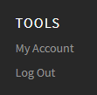
- When you have finished, please close all standards, and log out of Techstreet. ‘Log Out’ is found in the right hand side of the black tool bar at the bottom of the screen.

More information.
Further information on using Techstreet can be found from the ‘Help’ tab at the top of the Techstreet website. The User Guide, located on the Techstreet home page, when you are logged in, may also be of use.
Contact the library for more assistance.

(Images from Techstreet included with permission)

