## Australian Standards -Techstreet

Library guide

Box Hill Institute Library

studentweb.bhtafe.edu.au/library

**City (CAE) Campus:** Rooms B2.32 & 2.33, Second Floor, C1 (03) 8892 1684

**Elgar Campus:** Room E3.220, Level 2, B3

(03) 9286 983

**Lilydale Campus:** Room 290, Level 2, Building L5 (03) 8892 2520

**Nelson Campus:** Room G046, Ground Floor, B10 (03) 9286 9281

# General information.

Current Box Hill Institute staff and students can access the full text of all Australian Standards, plus selected international standards from our online subscription.

Users must first register for an individual account with Techstreet, and have the correct software installed onto their device.

Standards can be saved to your device for use while you are a student, or staff member of Box Hill Institute. They can also be printed out in full, using the print button in the top tool bar of Adobe. Our licence permits one print out of a standard per user. Printed or downloaded standards must only be used by the person who downloads them.

Standards can only be used on the device that they are downloaded on. To access a standard on multiple devices, download it on each device.

Standards are not accessible via Remote desktop.

Our account only allows two users to download standards from Tech Street platform at once. If you cannot get on, please try again later.

Multiple users can view standards simultaneously.

# Registering for an account.

1. Go to the Techstreet registration page at Open StudentWeb at <https://studentweb.bhtafe.edu.au/mod/page/view.php?id=1014747>
2. Log in with your usual StudentWeb log in. (STAFF: Your PC login is also your StudentWeb login)
3. The Standards registration screen appears.
4. Complete the form, and select ‘Sign up’.
   1. 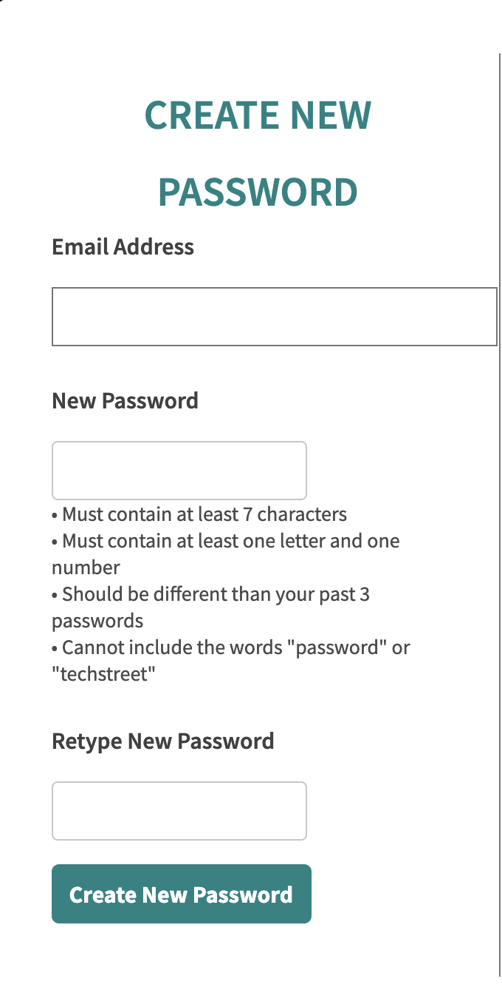You must use your Box Hill Institute email address to register.
   2. Select your usual campus as the location
5. Check your Institute email address for an email from Techstreet with a link to create your password. Look in your junk email, if this does not appear in a few minutes.
6. You will be prompted to create a password. You will need to use this 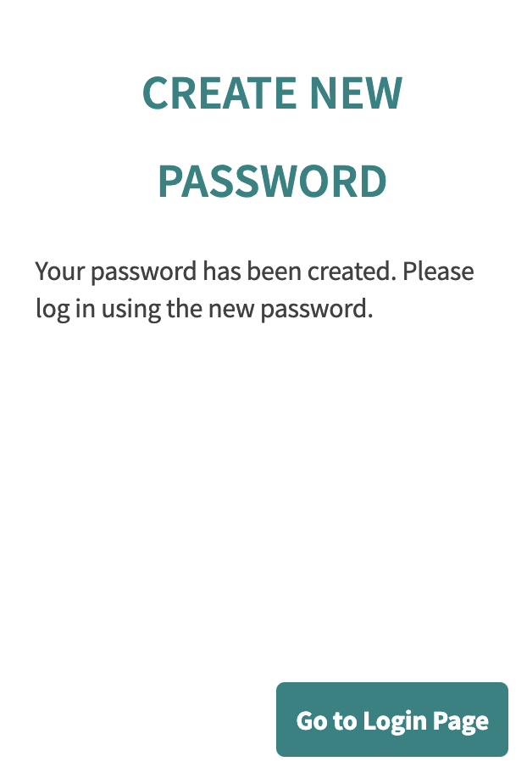password, anytime you are accessing standards.
7. You should get a message saying that your password has been created.

# Installing the required software

To access standards, you need to have Adobe Acrobat and FileOpen software installed on your device. Note that this software is already installed on many Institute PCs, including library PCs,   
so you may not need to complete this step.   
Specific instructions for Institute PCs are found later in this guide.

1. From step 7 above, select ‘Go to Login page’ or go to the Techstreet website at <http://subscriptions.techstreet.com/>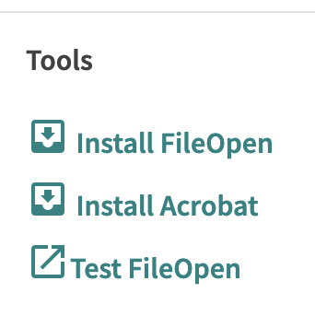
2. If you do not have Acrobat, select the Install Acrobat link on the Techstreet homepage. Next, select the download button for Adobe Acrobat Reader DC, and follow the steps to download it. When the file has downloaded, click on it to install Adobe on your device. Acrobat is already installed on Institute devices.
3. a. To install FileOpen on your own device, click the install FileOpen link on the Techstreet homepage. Select the appropriate version of FileOpen for your device. When the file has downloaded, click on the file to install it.

b. To install FileOpen on a staff device, open the Software Centre on your device. (Find this by typing Software into the search box at the bottom of your screen)

Select ‘FileOpen Client’ then install.

c. To install FileOpen on student PCs in classrooms, log a job with IT Services.

d. FileOpen is installed on all student PCs in the Library

FileOpen is installed if it shows as a Third party plug-in in Adobe. Third party plug-ins can be seen either under ‘Adobe Reader’ or under ‘Help’ depending on your device, and the version of Adobe. This is a safer way to check for FileOpen than the Test File Open link on Techstreet.

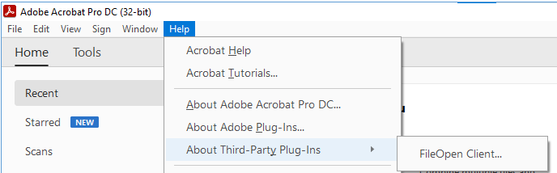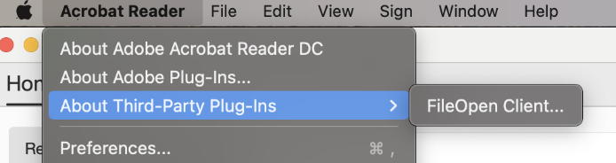You should now be ready to access Standards.

# Accessing standards

1. Login to the Techstreet website at <https://subscriptions.techstreet.com/sessions/new> If you can’t remember your password, select the ‘Forgot password’ link.
2. Search for standards by key word (e.g. electrical) or standard number (e.g. 3000) in the search box.

If you search by standard number, the top result should be the current version of the standard, including any amendments.

1. To open a standard, click on the document title.
2. 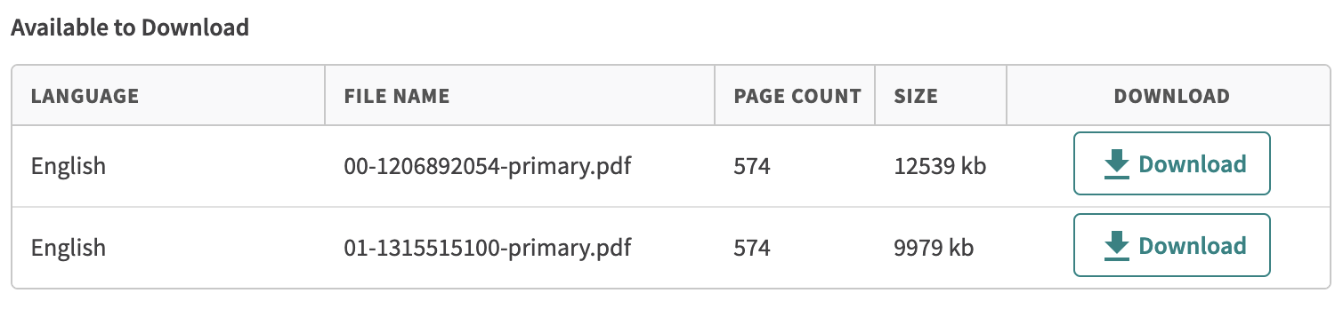Select ‘Download’ on the version that you want.
3. 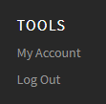Log out after use. ‘Log Out’ is found in the right hand side of the black tool bar at the bottom of the screen.

# Tips and more help

General

If the file is blank when opened, this often means that FileOpen has not installed. Follow the steps above to see if it has installed correctly.

IPhone:

If the standard is blank when opened, select the upload icon in the lower right hand corner of the screen, scroll along and select ‘FileOpen viewer’ as the app to use.

Chrome:

You may need to update settings in Chrome to download standards, rather than opening them in the browser

  
a. Within Chrome, select the three dots at the top right of screen, and select ‘Settings’

1. Select ‘Privacy and security’ and then ‘Site settings’

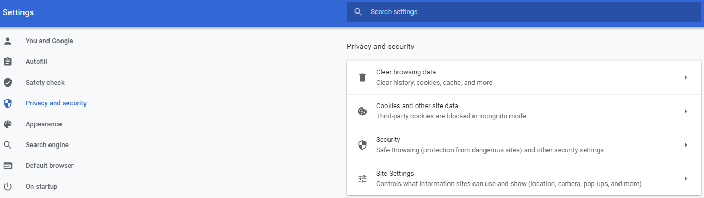

1. Select ‘Additional content settings’ and then PDF documents

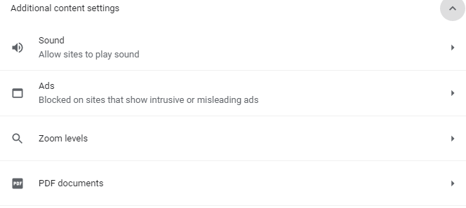

1. Make sure that ‘Download PDF files instead of automatically opening them…’ is selected



1. Return to Techstreet, and select ‘Download’
2. From the ‘Downloads’ folder on your device, right click on the file, and select “Open with Adobe Acrobat.
3. If Adobe does not appear as an option when you right click on the file, select ‘Open with’ and then chose Adobe.

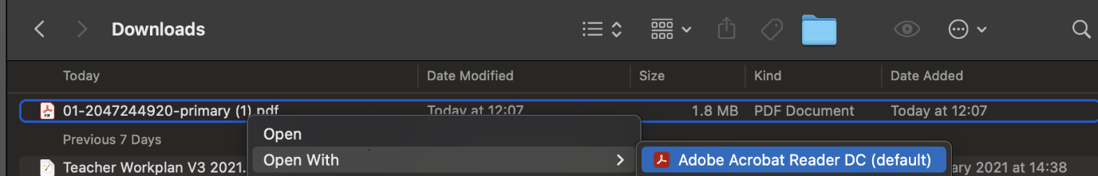

Firefox:

You may need to update settings in Firefox to download standards

1. Select Firefox in the top menu of your browser, choose ‘System preferences’ and ‘General’

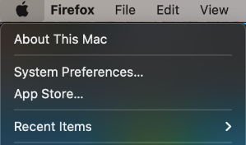

1. Select ‘General’ and under ‘Applications’, find Portable document format (PDF)

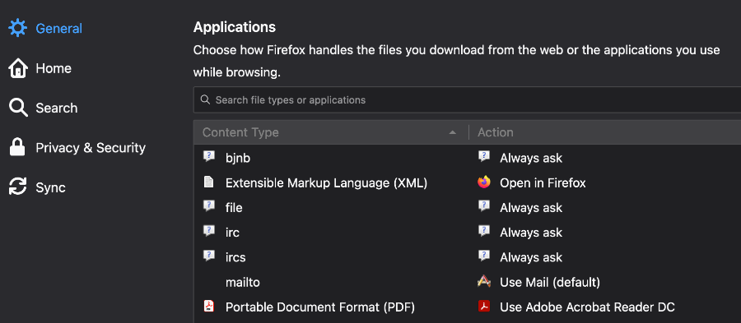

1. Change the ‘Action’ for PDFs to ‘Use Adobe Acrobat’ (you may have to select ‘Use other’ then browse to find Adobe on your device, if it does not appear in the list of options.)

# On Institute PCs

## Once FileOpen is installed, standards can be opened on Institute PCs.

1. In Techstreet, select ‘Download’ on the standard that you want.  Ignore the error message, if you get one.
2. Go to the Downloads folder on the computer and open file from there. The file should automatically open in Adobe, but if not, right click on the file, and select to open it with Adobe.



# More information.

Further information on using Techstreet can be found from the ‘Help’ tab at the top of the Techstreet website. The User Guide, located on the Techstreet home page, when you are logged in, may also be of use.

Contact the library for more assistance.

(Images from Techstreet included with permission)