Australian Standards - Intertek

Box Hill Institute Library
studentweb.bhtafe.edu.au/library
Elgar Campus Library: Room B3.201, Level 2, B3
(03) 9286 9283

General information.

Current Box Hill Institute staff and students can access the full text of all Australian Standards, plus selected international standards from our online subscription at https://i2.saiglobal.com/.
Users may receive an email to register an account with Intertek or register via the Library database page.
Standards can be saved to your device for use while you are a student or staff member of Box Hill Institute. They can also be printed out in full using the print button in the top tool bar of Adobe Acrobat. Our licence permits one print out of a standard per user. Printed or downloaded standards must only be used by the person who downloads them.
Our account only allows two users to download standards from Intertek platform at once.
If you cannot get access, please try again later.
Multiple users can view standards simultaneously.

Registering for an account.

- Go directly to the Intertek page (https://i2.saiglobal.com/) or via StudentWeb at
https://studentweb.bhtafe.edu.au/databases#standards-info
- Select New Registration
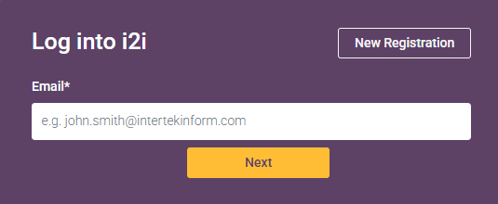
(Images from Intertek included with permission)

2a. Complete the fields marked * including your BHI student or staff email address. Create a password that meets the requirements.
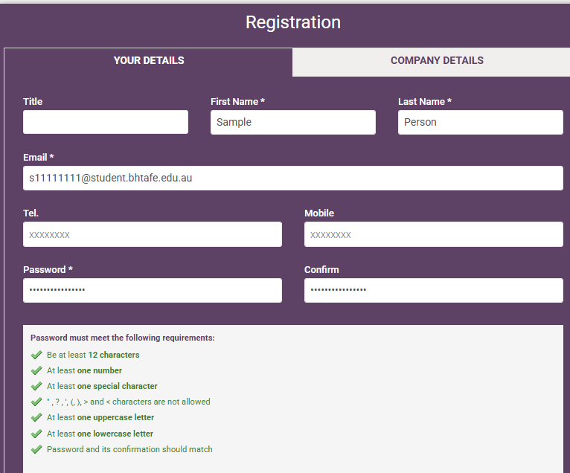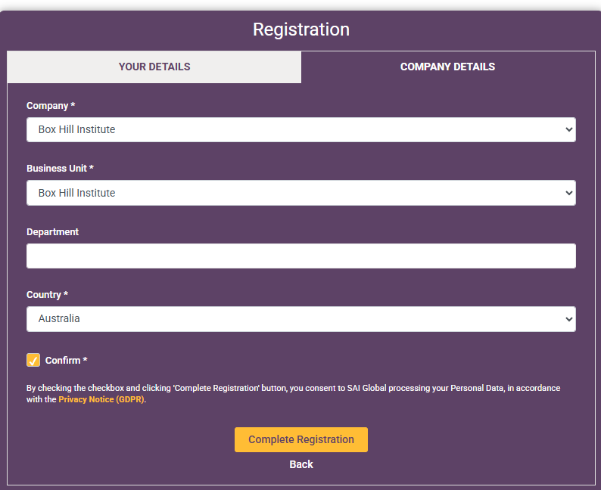
- Fill in the * fields as indicated – tick the Confirm box and then Complete Registration

Accessing standards
- Select AS - Australian Standards from the Publisher List and choose Status as Current.
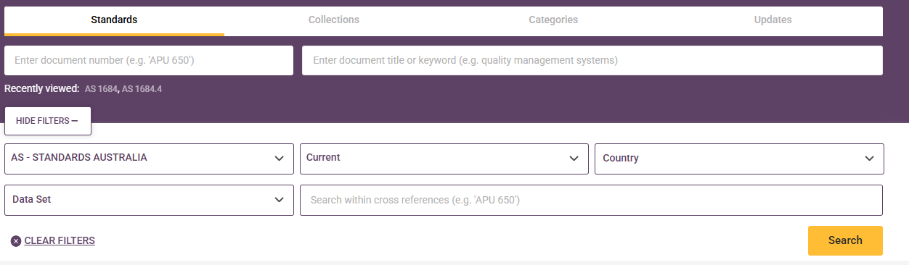
- Search for standards by standard number (e.g. 3000) or key word (e.g. electrical) in the search box.
- To open a standard, click on the document title.
- Select ‘Download’ on the desired version. If you want to print the entire standard, do so from the Adobe application. Do not print from web browser.
- Logout after use. ‘Logout’ is found on the top right under the profile icon.

More information.
Further information on using Intertek can be found in the User Guide, located on the Intertek home page, when you log in. Contact the library for more assistance. (Images from Intertek included with permission)

