BSBMED301 Interpret and apply medical terminology appropriately

Revision

Medical terms relating to position within the body

There are two studies that relate to the body.

The structures of the body are called ANATOMY.

The function of these systems is called PHYSIOLOGY.

Positional terms:
When studying anatomy and physiology, it is necessary to use directional terminology to give precise descriptions when referring to body parts and structures.
In anatomical terminology all parts of the body are described in relation to other body parts using a standardised body position called the anatomical position. An anatomical position is determined from a central imaginary line running down the centre or midline of the body. In this position the body is erect and facing forwards, arms to the side, palms facing forwards with the thumbs to the side, and the feet slightly apart with toes pointing forwards. For example if a medical practioner wants to point out the sternum (breastbone) to someone who knows where the clavicle (collarbone) is, they could say that the sternum is inferior (below or towards the lower part) and medial (towards the middle of the body) to the clavicle.
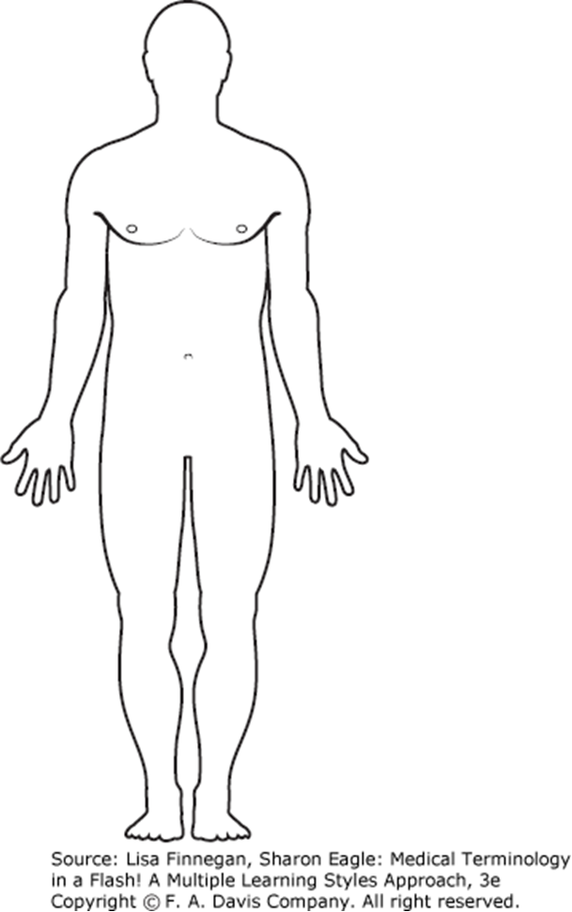
Label the positional terms

Term | Position within the body/definition | One example of how the term may be used

Anterior

Posterior

Distal

Medial

Inferior

Proximal

Superficial

Superior

BODY PLANES:
The structural plan of the human body may also be divided into planes (imaginary flat surfaces) that pass through it.
The sagittal plane runs lengthwise from front to back and divides the body into right and left sides.
The frontal plane runs lengthwise from side to side, dividing the body into ventral and dorsal (front and back sections)
The transverse plane, also called the horizontal plane, cuts the body into upper and lower parts. These are known as the cranial (head) and the caudal (tail) portions

BODY CAVITIES
The internal organs of the human body are contained in spaces that are called body cavities. Body cavities may be distinguished in the body by dividing the body into right and left helves. The body cavities include:
Term | Position within the body/definition | One example of how the term may be used

Dorsal cavity

Cranial cavity

Vertebral or spinal canal

Ventral body cavity

Pleural cavities

Pericardial cavity

Abdominal cavity

Pelvic cavity

