Student Details: Student to complete
Student Name:
Student ID:
Student Declaration:
By signing below, I declare that the work submitted here is my own work and it does not include work, which is plagiarised, copied in whole or in part from another student or other source such as published books, internet, or journals without due acknowledgement in the text.
Student Signature: | Date:
Assessment Details: Teacher to complete
Course National ID and Title | HLT33115 Certificate III in Health Services Assistance
Unit/s National ID and Title | HLTWHS001 – Participate in workplace Health & Safety
Assessment Task number and name | Assessment Task 3: In Class/remote Group Activities 1,2,3/Emergency Scenario Activity 4
Date due: | Date submitted:
Assessor Name:

Add Other Group Member Names below, for Activity 1, 2, 3

Student Names for Activity 1, 2 & 3 (Group of 4). | Student ID
2.
3.
4.

Instructions to learner:
This assessment comprises of four (4) parts:
Activity 1: Hazard Identification
Activity 2: Risk Assessment
Activity 3: Incident Report
Activity 4: Identification of signage, emergency exits, workplace audit, evacuation plan &
Evacuation (Bomb Threat) Scenario (On Campus)

  - Please read this Assessment before commencing this Assessment Task
- All Learners are to participate in groups of four (4) to complete Activity 1,2 & 3.
- All Learners will participate in groups of ten (10+/-) to complete Activity 4
- All learners must use contents from the Emergency Evacuation bag as part of their scenario in Activity 4
- Each learner is to engage in all aspects of the group activities.
- All areas of this Assessment Task must be completed by each learner.
- Please be sure all assessment tasks have all participating students group names and signatures on them before submission.
- Please complete and sign a coversheet and attach this to your assessment.
- Each learner is to upload their completed assessment at the end of session.
- To be deemed Satisfactory (S) for this unit, you must have completed areas of the task. Where you have been deemed Not Satisfactory (NS), you will be offered a resit at a time that is both suitable to the assessor and your assessor.

Instructions to Assessor:

- Assessor, please group students into groups of four (4) for Activity 1,2,3.
- Assessor, please group students into groups of ten (10) for Activity 4 (On Campus)
- Please be sure all students participate in all aspects of this group activity and all assessment questions have been completed by all students before submission of assessment.
- Assessor, please have the Emergency Evacuation Bag
- Please be sure all assessment tasks have students group names and signatures on them before submission.
- Please complete and sign a coversheet and attach this to your assessment.
- Each learner is to upload their completed assessment at the end of session.
- To be deemed Satisfactory (S) for this unit, you must have completed areas of the task. Where you have been deemed Not Satisfactory (NS), you will be offered a resit at a time that is both suitable to the assessor and your assessor.

Activity 1 – Hazard Identification
- Walk around the simulation ward/theatre room and identify the hazards present. List these hazards in the table below (Minimum 8 hazards must be identified)
- For each hazard, indicate what type of hazard it is.
Hazard Identified | What type of hazard is it?  - Slip, trip & fall  - Chemical/biological hazard  - Manual handling  - Other

Activity 2 – Risk Assessment
- From your list of eight (8) hazards in activity one (1) select three (3) of these hazards.
- Using your Risk Assessment Matrix below, identify the levels of risk for each of the three (3) hazards you have selected.
- For each of the three (3) hazards, identify the risk and consequences. Following this, you will need to complete an incident and hierarchy of control template (below) to control the hazard. In some instances, elimination is not possible, think of the other measures.
Hazard | Level of risk  (rare/unlikely) etc. | Consequence  (Impact)
Risk Assessment Matrix
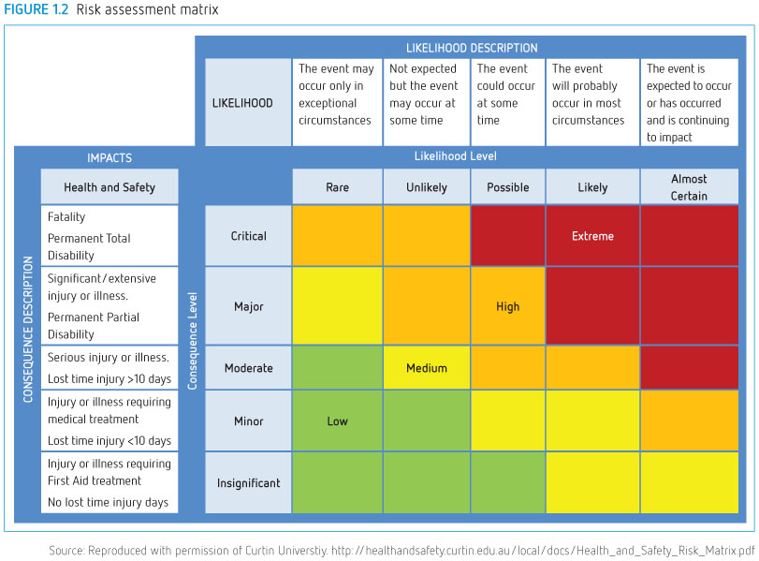

Activity 3 – Incident Report
From Activity 2, complete the incident report form for one (1) incident that you identified in Activity 2.
Incident Report Form
Part A – Details of the Incident
Date & time of the incident: _____/____/_____ ___:___AM/PM
Location of Incident: ______________________________________________________________
Reported by: ________________________________________________Date: _______________
Task/activity at time of incident: _____________________________________________________
Plant/equipment involved (if relevant): _______________________________________________
Witnesses (if applicable): __________________________________________________________
Name: __________________________________________
Contact number: __________________________________
Name: __________________________________________
Contact number: __________________________________

Part B – Details Injured person (if relevant)
Name: ___________________________________________________ Age: _________________
Occupation: ______________________________________________
Body part/s affected by the incident: ________________________________________________
Details of first aid/medical treatment provided: _______________________________________
Treating officer’s signature: _______________________________ Date: __________________
Was time away from required: YES/NO Number of days absent: ________________
Was a return-to-work plan prepared YES/NO Return-to-work date: ___________________
Was a workers’ compensation form lodged? YES/NO

Activity 3 - Consultation with work colleagues about the incident
Once you have completed your incident report, organise a meeting (groups of 4) to discuss the following:
- Consult with your manger/WHS Rep about the incident. (One (1) student will need to act as the Manager or WHS Rep)
- Discuss how you would implement safe work practices by completing and implementing the hierarchy of control measures for the incident.
- Discuss your stress levels.
- How would you maintain currency in your job role?

Names of those who attended the meeting:

- Consultation with your manger/WHS Rep about the incident. Provide your discussion points below and complete the Hierarchy of Control about the identified incident in Activity 2.

- IMPLEMENTING THE HIERARCHY OF CONTROL
Task: _____________________________________________Date: _____________________

Hazard/s identified: __________________________________________________________

Risks: ______________________________________________________________________

____________________________________________________________________________

If you answer YES to any of the below, complete the fourth column
Hierarchy of control | YES | NO | Provide Details
STAGE 1
Can you eliminate the risk altogether?
STAGE 2:
Can you substitute the hazard for a less hazardous process or plant?
STAGE 3:
Can you isolate the hazard: e.g., by using barriers?
STAGE 4:
Can you engineer controls to reduce the risk?
STAGE 5:
Do you need to implement administrative control: e.g. signs, updated policies?
- Following the incident, how would you manage your stress levels in the workplace?

- How would you maintain your currency in your job role?

Activity 4 – Identification of signage & emergency exits and evacuation plan/evacuation & workplace audit & Scenario.
- Student Name: _______________ Student Number: _____________Date: _____
Other Group Member Names: Activity 4
- Student Name: _______________________________ Student number: _________
- Student Name: _______________________________ Student Number: _________
- Student Name: _______________________________ Student Number: _________
- Student Name: _______________________________ Student Number: _________
- Student Name: _______________________________ Student Number: _________
- Student Name: _______________________________ Student Number: _________
- Student Name: _______________________________ Student Number: _________
- Student Name: _______________________________ Student Number: _________
- Student Name: _______________________________ Student Number: _________

Instructions to Students:
- Activity 4 is comprised of three (3) parts:
Part 1: Identification of all workplace WHS signage & emergency exits (Elgar B3.Ground Floor)
Part 2: Workplace audit
Part 3: Evacuation plan & BHI Evacuation – Followed workplace procedures for Simulated Emergency Situation

Part 1: In groups of ten (10), walk around BHI Elgar Campus Building 3 Canteen Ground Floor
Identify safety signage in this area and list eight (8) of these signs below:

Part 2: Using BHI evacuation plan below, walk around BHI Elgar Campus Building 3 Canteen
Ground Floor, identify, and list your nearest emergency exits in readiness for an emergency evacuation (later in the day).

Using your Emergency Procedure Assembly Area Elgar Campus Map on the next page, highlight on the map the exit path that you will take to arrive at the designated assembly area – KINGSLEY GARDENS.

Here is an example of an exit route
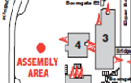

On the map below, highlight your exit path from building 3 to the designated assembly point – Kinsley gardens

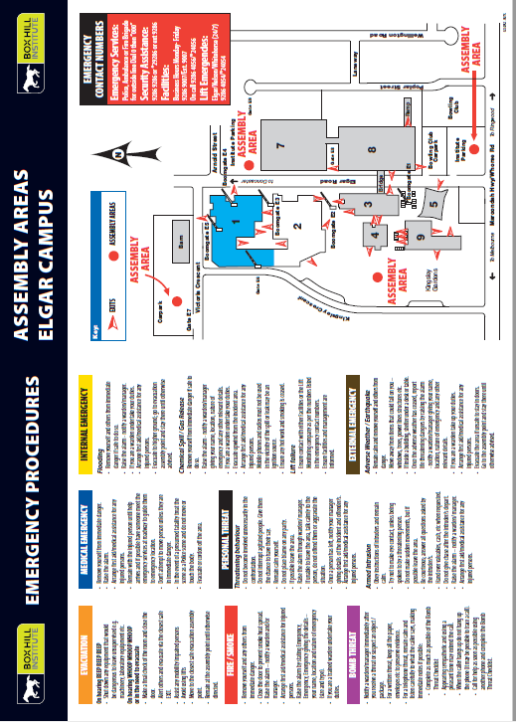
Part 2: As you walk around the BHI Elgar Campus Building 3 Canteen Ground Floor complete the Work Health Safety – Audit Inspection checklist below.
Work Health Safety - Audit Inspection
WHS BUILDING AUDIT CHECKLIST
Inspection by: | Date:
Location:
Ground/Flooring/Walkways |  | Yes | No | N/A
Uneven flooring surfaces?
Ramp access?
Walkways clear, clean free of clutter?
Doorways are kept clear?
Building Facilities |  | Yes | No | N/A
Toilet facilities?
Disabled toilet facilities?
Adequate lighting?
Adequate waste bins?
Are bins regularly emptied?
Ceilings are intact?
Steps/stairs are in good condition?
Handrails available where appropriate?
Furniture is safe & in good condition?
Hanging displays are not hazardous e.g. bulletin boards
Appropriate storage facilities?
Shelving is secure & safe?
Rooms are clean & tidy?
Adequate ventilation?
Fire Safety & Emergency Response |  | Yes | No | N/A
Evacuation procedure posters displayed?
Fire equipment signage?
Fire equipment tag & tested?
First Aid equipment?
First Aid signage?
Warning signs?
Electrical |  | Yes | No | N/A
Electrical cables secured safely
Electrical equipment is tag & tested where appropriate?
Hazardous Substances |  | Yes | No | N/A
Hazardous substances are labeled & stored appropriately
MSDS/SDS are readily available & current (within 5 years)
Other |  | Yes | No | N/A
PPE is available, in good condition & easily accessible?
Noise level is not hazardous?

WHS BUILDING AUDIT CHECKLIST
Action required: | By whom: | Date due:

Part 3: Evacuation plan & BHI Evacuation - Followed workplace procedures for Simulated Emergency Situation)

Emergency Response Scenario for Simulation Workplace Evacuation

- Student Name: _______________ Student Number: _____________Date: _____
Other Group Member Names: Activity 4
- Student Name: _______________________________ Student number: _________
- Student Name: _______________________________ Student Number: _________
- Student Name: _______________________________ Student Number: _________
- Student Name: _______________________________ Student Number: _________
- Student Name: _______________________________ Student Number: _________
- Student Name: _______________________________ Student Number: _________
- Student Name: _______________________________ Student Number: _________
- Student Name: _______________________________ Student Number: _________
- Student Name: _______________________________ Student Number: _________

Student Instructions:

Resources required:
- Emergency Procedure Assembly Area Elgar Campus Map on page 20, where you have highlighted your exit path to the designated assembly area and use this for the evacuation scenario.

- Emergency Evacuation Bag: (per bag)
- 2 x Emergency response folders
- 1 x Warden Identification (Red Hat)
- 2 x Emergency Personnel (Yellow Hat)
- 1 x First Aider (Green Hat)
- 1 x First Aid Kits
- Hair Nets
- Phone
- Emergency scenarios
- List of names for checking at evacuation point (Kingsley Gardens)
- Emergency response criteria checklist (for teacher)

Classroom Scenario
Whilst working at Box Hill Institute Hospital, you will be required to undertake an emergency evacuation as a result of a BOMB THREAT.

- Your assessor will divide the class into groups of ten (10) students.

- Read and familiarise yourself with all aspects for Activity 4 (including the Emergency Evacuation BOMB THREAT) at the end of this document.

- Each group will be given an Emergency Evacuation Bag, and you are required to use all items from the bag during the scenario.

- Each group will spend 30 minutes familiarising the Box Hill Institute Hospital Emergency exits, evacuation route and emergency assembly areas & Policy & Procedural documentation. (See Evacuation plan BOMB THREAT). All students should familiarise themselves with all designated roles.

- Designated Roles:
Each Group are to choose a total ten (10) Members: you will need to assign members to the each of the following roles:
1x Member to be the warden.
2 x Members to be Emergency Personnel
1 x Member to be First Aider
1 x Member to take the emergency Bomb Threat Phone call and complete the Phone Threat Checklist (This is attached to this document) and raise a CODE PURPLE
3 x Members to act as staff on the ward.
2 x patients with injuries (both are ambulant)

- Each group of ten (10) students will undertake the evacuation separately, using the resources from the Emergency Evacuation Bag and playing the designated roles as per the list above to the assembly point. (The other groups will need to wait until it is your turn).

- All students to read the instructions for EVACUATION PROCEDURES FOR BOMB THREAT and complete the BOMB THREAT call checklist, however, the person who is designated to that role, will role play it for the scenario.

- Your teacher will play the role of the person making the BOMB threat from 2 scenarios.

- The member taking the BOMB THREAT call should record all details on the form and notify that a CODE PUPLE should be called. The number is 400.

- The warden will direct staff to conduct the emergency response – CODE PURPLE.
- Emergency personal should do a check of the staff areas, including under desks, cupboards etc and make sure that they have the correct number of staff for evacuation (use sheet below). Staff should notify the Warden if staffs are missing from the list.

- Once a check has been undertaken and staffs have been accounted for (or not), notify warden of current the situation. Please maintain constant communication throughout the evacuation process. You should also advise the First Aider of any injuries and refer to First Aid as required throughout the emergency evacuation if required.

- First Aider should collect First Aid kit from Emergency evacuation bag and maintain communication throughout the emergency evacuation and manage as required.

- Warden to guide all staff to emergency evacuation point and check that all staff is present and accounted for.

- After the emergency response, all staff members should reflect on how they responded to the incident.
Designated Role | Name of Person Playing Role
1x warden
*Collect your designated equipment from your teacher at time of evacuation
2 x Emergency Personnel
*Collect your designated equipment from your teacher at time of evacuation
1 x First Aider
*Collect your designated equipment from your teacher at time of evacuation
1 x emergency staff to take BOMB Call and raise a code PURPLE.
*Collect your designated equipment from your teacher at time of evacuation
3 x ward staff  2 x patient (1x injury to hand/1x dressing to knee) *collect your designated equipment from your teacher at time of evacuation. | - staff  - staff  - staff  - patient  - patient
Did you? –

- Check list of all staff accounted for: Yes/No
- Action taken to report missing staff: Yes/No
- Action Required:

Following the emergency evacuation, reflect on your own performance:

EVACUATION PROCEDURES
Upon hearing the alarm or when directed by a warden -
Prepare to evacuate.
- Get your workplace ready to be left unattended. Shut down computers; turn off gas and electrical equipment, if safe to do so.
- For fire, close the doors as you go – do not lock them. In the case of a bomb threat, leave doors open.
- Assist any person in immediate danger.
- Leave the building via the nearest safe route.
- Obey all directions from wardens.
- Move calmly to the assembly point or other advised area and stay there until the All Clear has been given.
- Follow closely the instructions of emergency services personnel and campus wardens.
- Wait for the OK to re-enter the building.

FIRE
- Ring 0 000 and provide details of the fire then ring security on 400.
- Assist any person in immediate danger (only if safe to do so).
- If safe to do so, close doors to minimise spread of the fire.
- Attack the fire only if safe to do so.
- Contact nearest warden and follow their directions.
- Assist with the evacuation of mobility impaired occupants.
- Move to the nominated evacuation assembly point, and stay there until the All Clear has been given.
- Follow closely the instructions of emergency services personnel and campus wardens.

MEDICAL EMERGENCY
Assess the situation -
- Do not move a casualty unless they are exposed to a life-threatening situation.
- Contact the nearest first aid officer.
- In extreme emergency situations contact the ambulance service by dialling 0 000 then ring security on 400.
- Arrange for the ambulance to be met at the front gate or other nominated area.
- Remain with the casualty and administer first aid as appropriate until assistance arrives.
- Follow closely the instructions of emergency services personnel and campus wardens.

BOMB THREAT
On receipt of a telephone bomb threat:
- Keep the caller talking (do not hang up).
- Remain calm and do not say or do anything that may encourage irrational behaviour.
- Ask someone else to ring 400.
- DO NOT use mobile phones. Turn them all off.
- Complete the phone threat checklist over the page.
- Follow the warden’s instructions.
- Evacuate the building via alternate exits, leaving doors and windows open.
- Take personal belongings with you, noting any suspicious parcels in your area as you leave.
- Move to assembly point maintaining a clear distance from parked vehicles.
- Follow closely the instructions of emergency services personnel and campus wardens.

CIVIL DISTURBANCE
- Keep well clear of the disturbance and do not say or do anything that may encourage irrational behaviour.
- Consider ”locking down” the building to prevent unauthorised entry.
- Follow closely the instructions of emergency services personnel and campus wardens.
- Evacuate the building only if instructed to do so by emergency services personnel or campus wardens.

ATTACK OR ARMED THREAT
- Keep well clear of the intruder and do not say or do anything that may encourage irrational behaviour.
- Notify security 400 and police 0 000.
- Note as many details as possible.
- Follow closely the instructions of emergency services personnel and campus wardens.
- Evacuate the building only if instructed to do so by emergency services personnel or campus wardens.
- Stay clear of windows.
PERSONAL PREPARATION
- Know the location of emergency exits in your building.
- Plan an escape route from your office to each exit.
- Familiarise yourself with the location of any break glass fire alarms in your building.
- Note the location of fire extinguishers.
- Familiarise yourself with the names and locations of your building warden and nearest floor wardens.
- Familiarise yourself with the identity and location of the first aid officers and first aid kits.

FIRST AID KITS
First aid kits are located in the following areas:

Building/Room No/Area
E3.316

YOUR WARDENS AND EMERGENCY PERSONNEL ARE:

Area | Name | Ext
Building 3 - Warden | Jose Taylor | 1111
Building 3 – Emergency Personnel | Jan Smith | 1112
Building 4 - Emergency Personnel – First Aid | Thomas Ng | 1113
Building 5 - Emergency Personnel | Navinder Kaur | 1114

Assembly Point

In the event of fire – Kingsley Gardens, Victoria Cres Box Hill

In the event of bomb threat - Kingsley Gardens, Victoria Cres Box Hill
OR follow the instructions of your wardens.
Your personal safety is the most important.
Factor in an emergency. Date of preparation 21/10/2019

Date of preparation: 21/01/2019 V1.0
PHONE THREAT CHECKLIST
KEEP CALM

Name (Print) Phone No Signature

GENERAL QUESTIONS TO ASK THE BOMB CALLER
1. What is it?

2. When is the bomb going to explode? OR
When will the substance be released?

3. Where did you put it?

4. What does it look like?

5. When did you put it there?

6. How will the bomb explode? OR
How will the substance be released?

7. Did you put it there?

8. Why did you put it there?

Chemical/Biological Threat Questions
1. What kind of substance is in it?

2. How much of the substance is there?

3. How will the substance be released?

4. Is the substance a liquid, powder or gas?

Bomb Threat Questions
1. What type of bomb is it?

2. What is in the bomb?

3. What will make the bomb explode?

Exact Wording of Threat

Caller's Voice
Accent (specify)
Any impediment (specify)
Voice (loud, soft etc)
Speech (fast, slow etc)
Diction (clear, muffled etc)
Manner (calm, emotional etc)
Did you recognise the caller?
If so, who do you think it is?
Was caller familiar with the area?
Threat Language
Well spoken.
Incoherent
Irrational
Taped
Message read by caller.
Abusive
Other
Background Noises
Street
House
Aircraft
Voices
Music
Machinery
Other
Local call
STD call
Notes

Other
Gender of caller Male / Female Estimated age
Call Taken
Date Time
Duration of call
Number called
Action (0btain details from Supervisor)
Report call immediately to
Phone Number
OR Security 400

Please report these details to Security and the Building Warden as soon as possible

Use additional paper as required

Follow workplace procedures for reporting hazards.

Unit of Competency:
HLTWHS001 Participate in workplace health and safety.
Student/Assessor instruction:
This task must be Satisfactorily (S) demonstrated on at least one (1) occasion.

Observable behaviours / skills to be demonstrated by the student. | Observation  1 |  | Reassessment 1 |  | Reassessment 2 |  | Assessor Feedback
 | S | NS | S | NS | S | NS
Identify existing and potential hazards in the workplace | ☐ | ☐ | ☐ | ☐ | ☐ | ☐
Report hazards(s) using the appropriate method | ☐ | ☐ | ☐ | ☐ | ☐ | ☐
 | S/NS |  | S/NS |  | S/NS
Location (Simulation /Workplace): | Simulation |  | Simulation |  | Simulation
Assessor’s signature:
Date: | / / |  | / / |  | / /
Overall student’s performance: ☐ Satisfactory (S) ☐ Not Yet Satisfactory (NS)
Feedback:

Student Signature: |  |  |  |  |  |  |  | Date: / /
Assessor Name & Signature: |  |  |  |  |  |  |  | Date: / /

Scenario: Evacuation
You are an HSA working in the hospital today. The emergency codes sound to indicate a Bomb threat warning and then the evacuation code follows this announcement. There are two (2) patients in the area (one (1) has had hand surgery the other has a dressing to the knee both are ambulant). You are to provide appropriate assistance following the service provider’s procedures for Bomb Evacuation to the closest evacuation point. Use should assume their roles and implement the evacuation process immediately. All equipment will be provided to those who assume designated roles for evacuation. Your teacher will provide all the equipment.

Follow workplace procedures for a simulated emergency.

Unit of Competency:
HLTWHS001 Participate in workplace health and safety.
Student/Assessor instruction:
This task must be Satisfactorily (S) demonstrated on at least one (1) occasion.

Observable behaviours / skills to be demonstrated by the student | Observation  1 |  | Reassessment 1 |  | Reassessment 2 |  | Assessor Feedback
 | S | NS | S | NS | S | NS
Shut down equipment that would be dangerous to leave unsupervised | ☐ | ☐ | ☐ | ☐ | ☐ | ☐
Make a final check of the room and shut the door. | ☐ | ☐ | ☐ | ☐ | ☐ | ☐
Alert others and evacuate via the closest safe EXIT | ☐ | ☐ | ☐ | ☐ | ☐ | ☐
Move to the closest safe Evacuation Assembly Area (EAA) (as per Evacuation Wall Charts or instruction from Wardens). | ☐ | ☐ | ☐ | ☐ | ☐ | ☐
Remain at the EAA until otherwise advised. | ☐ | ☐ | ☐ | ☐ | ☐ | ☐
Report any missing people to a Warden or the Chief Warden. | ☐ | ☐ | ☐ | ☐ | ☐ | ☐
 | S/NS |  | S/NS |  | S/NS
Location (Simulation /Workplace): | Simulation |  | Simulation |  | Simulation
Assessor’s signature:
Date: | / / |  | / / |  | / /
Overall student’s performance: ☐ Satisfactory (S) ☐ Not Yet Satisfactory (NS)
Feedback:
Student Signature: |  |  |  |  |  |  |  | Date: / /
Assessor Name & Signature: |  |  |  |  |  |  |  | Date: / /

